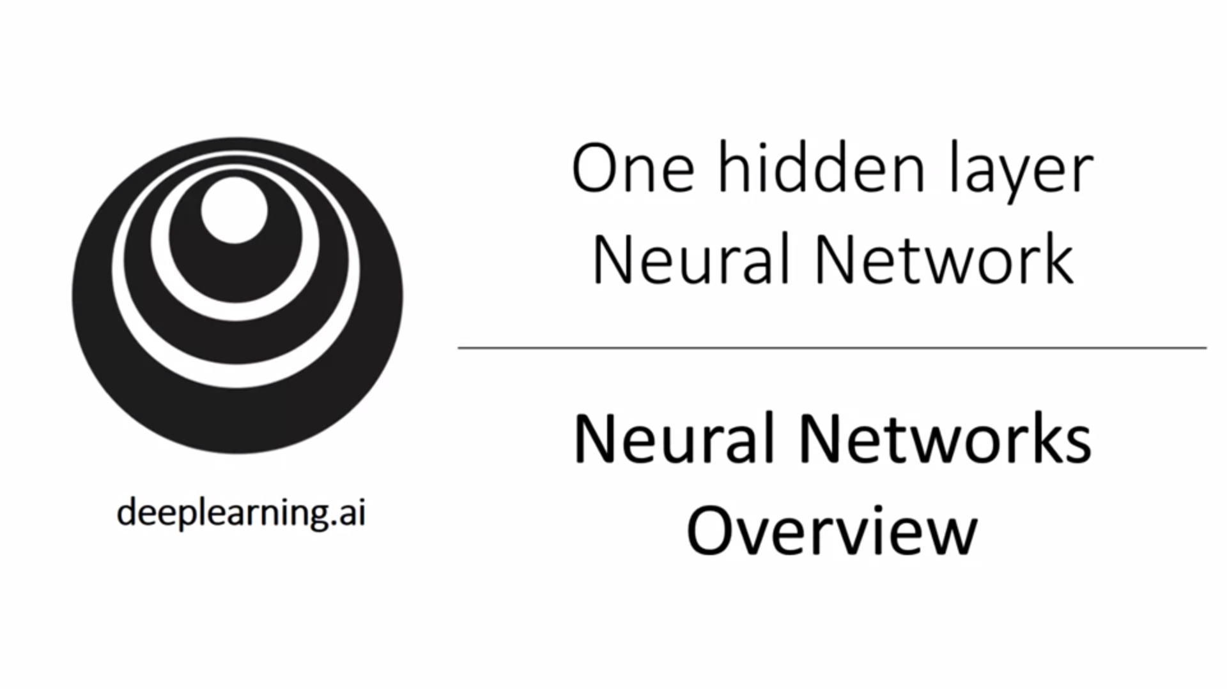

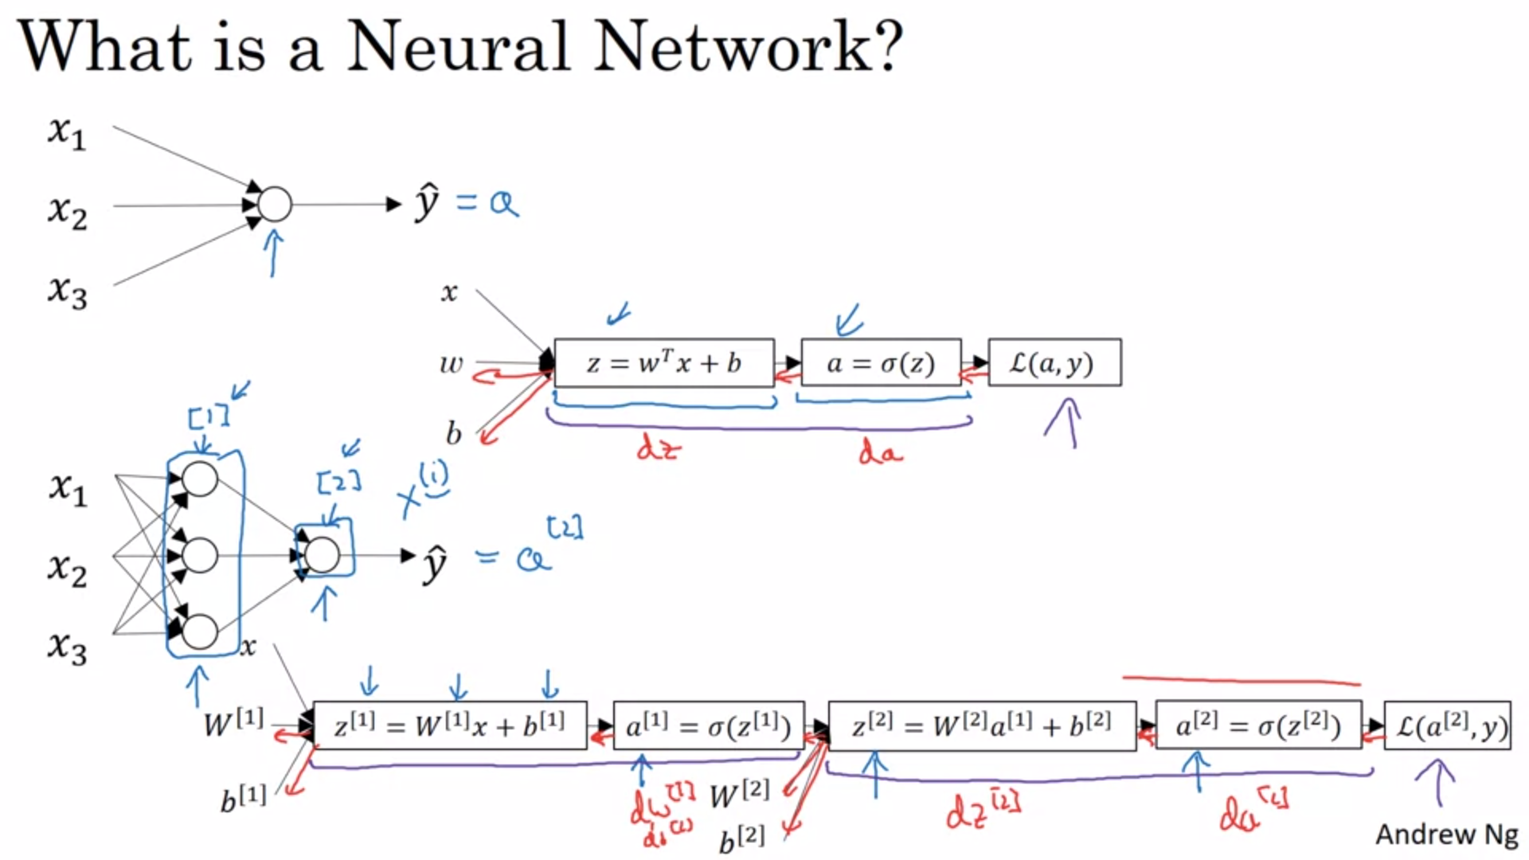

Last week we had seen logistic regression.

You can form a neural network by stacking together multiple sigmoid units.

Backward propagation also works in the same way as in logistic regression (with the computation graph).

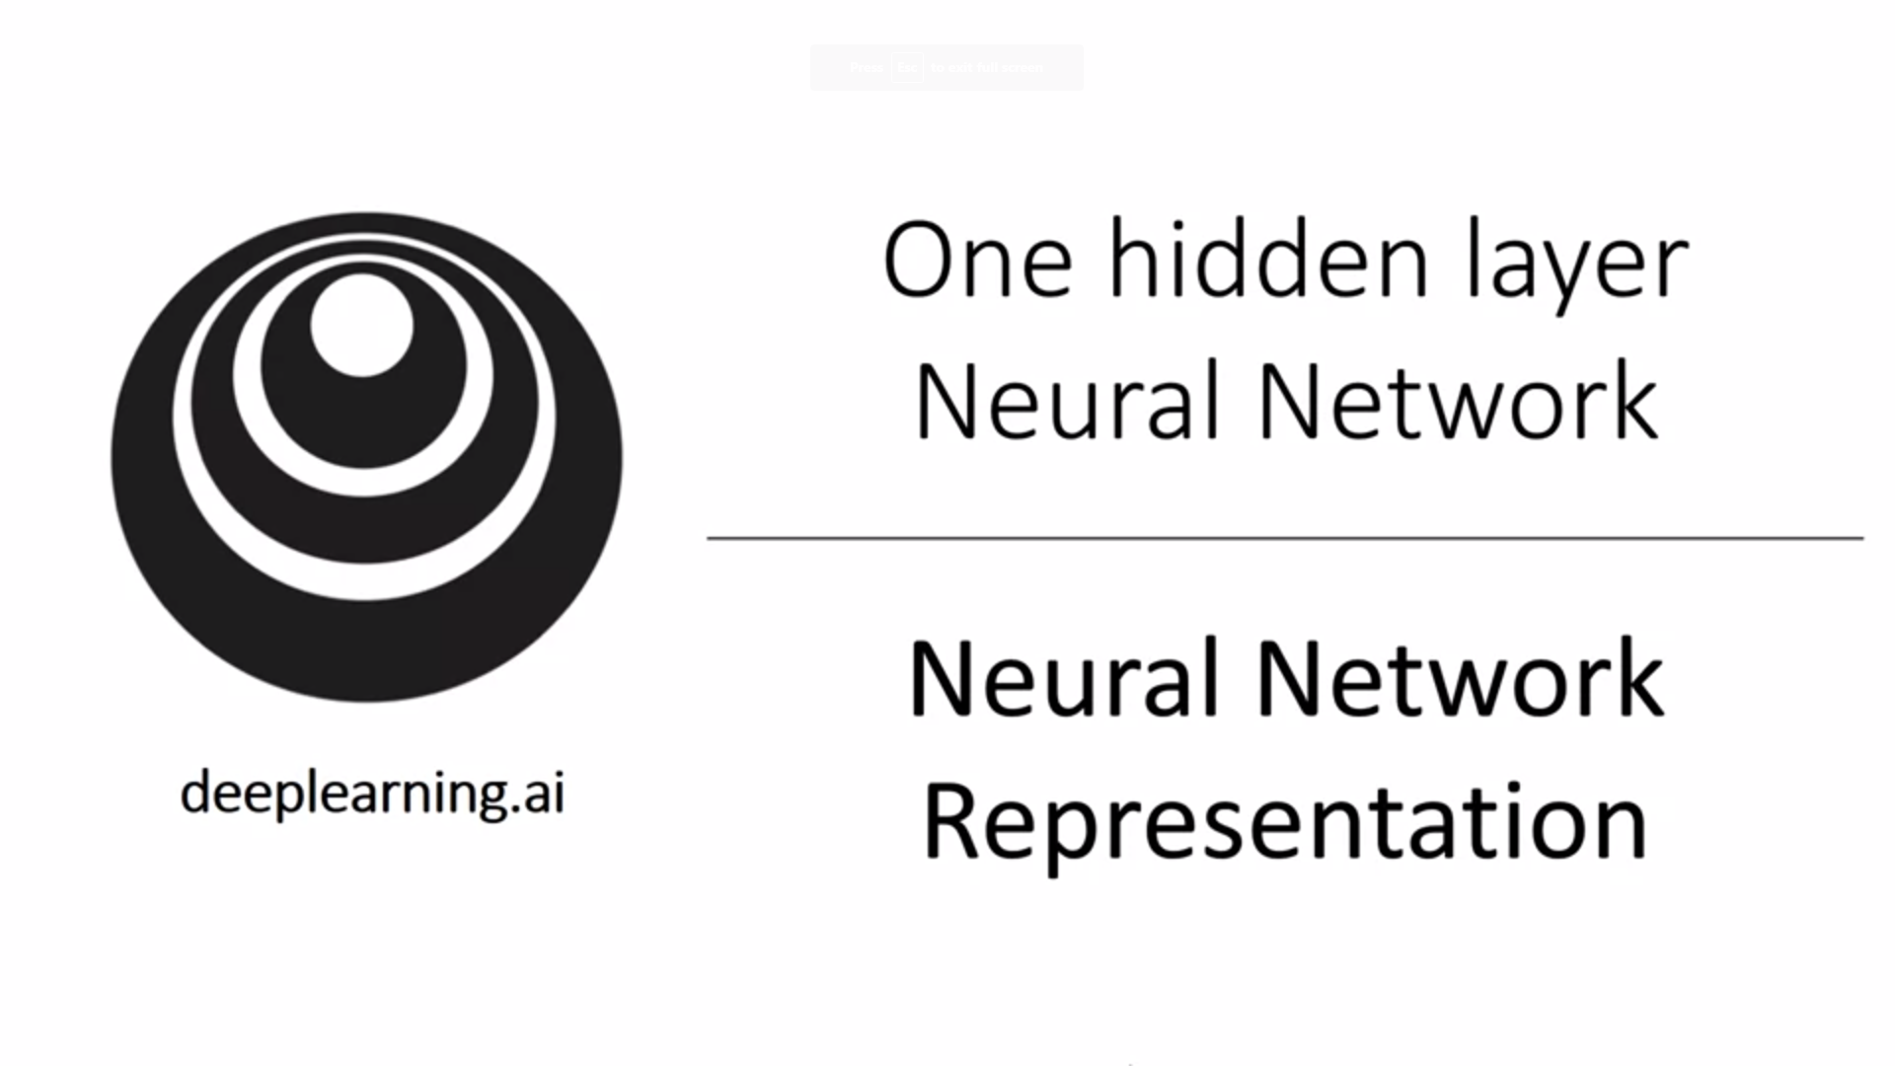

Input features x1, x2, x3 are stacked up vertically.

Things in the hidden layer are not seen in the training set, hence the name.

We do not count the input layer when counting layers.

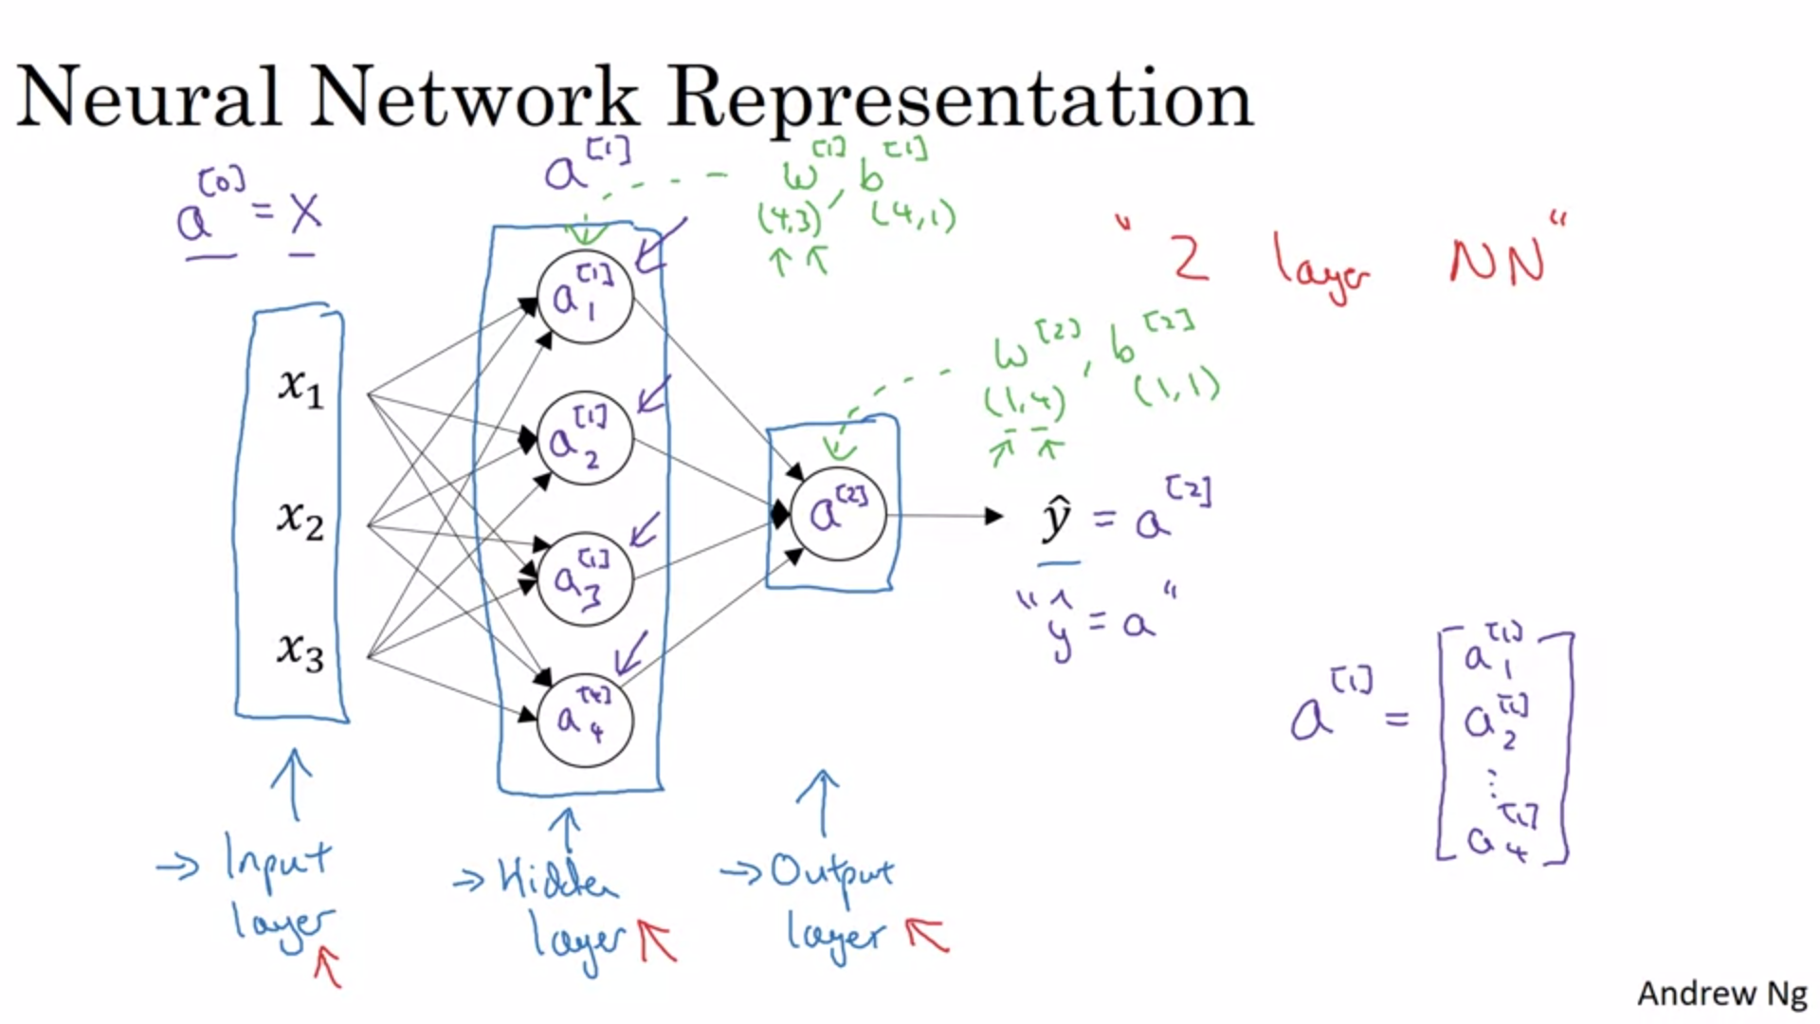

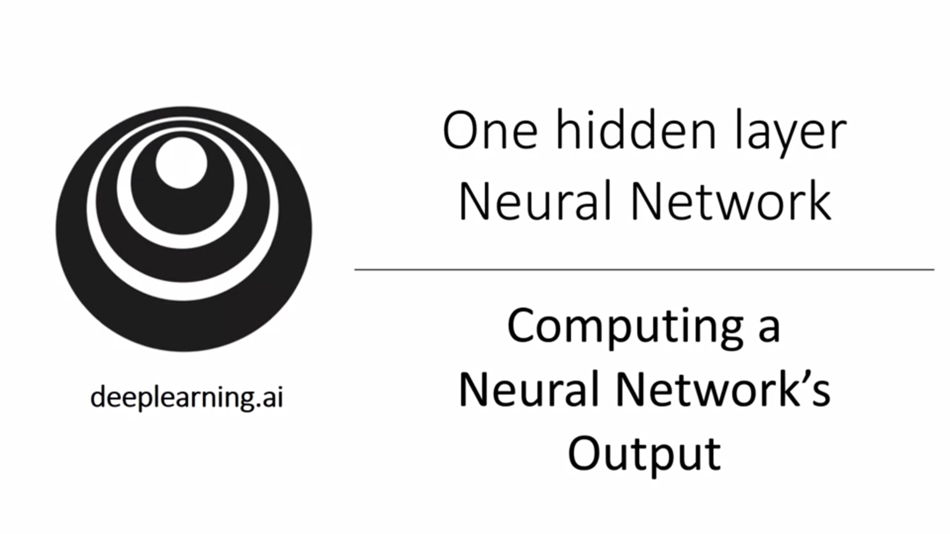

The circle represent two steps of computation: linear combination and activation function.

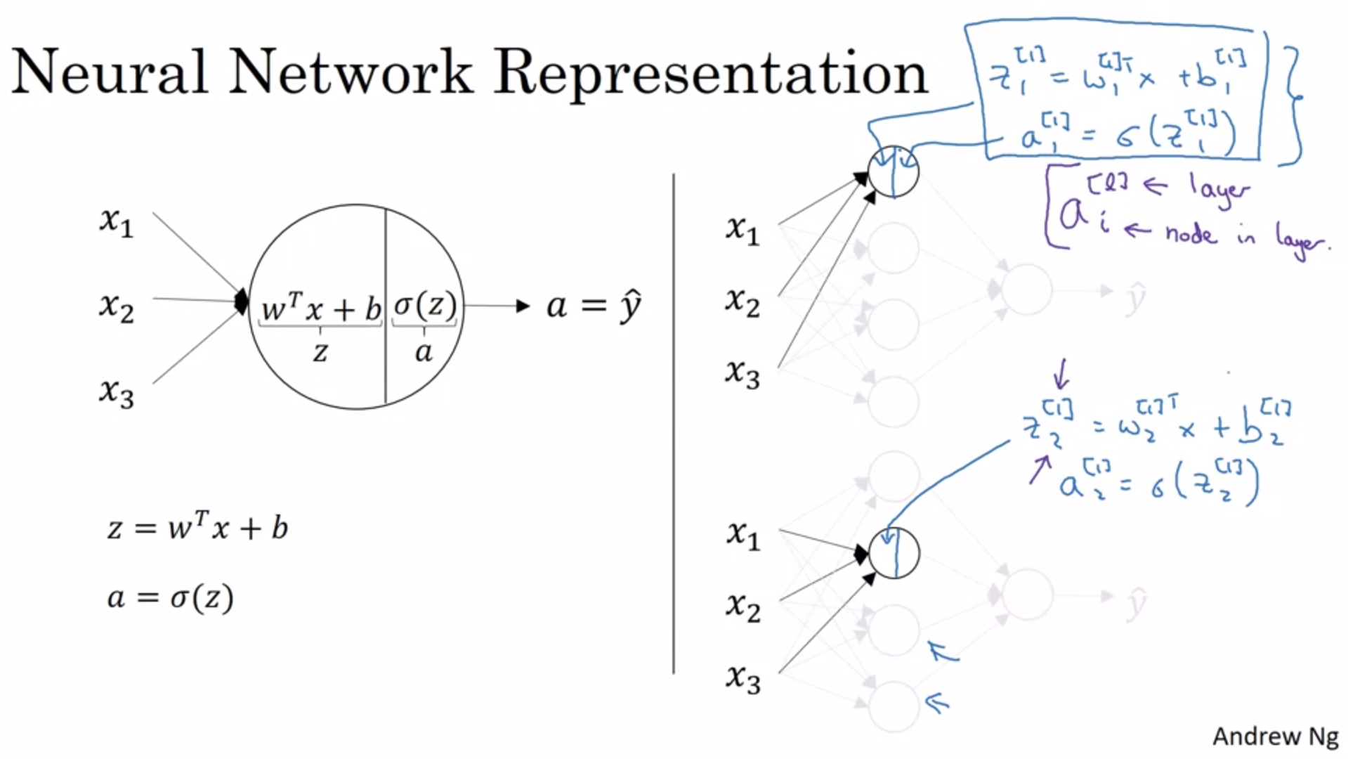

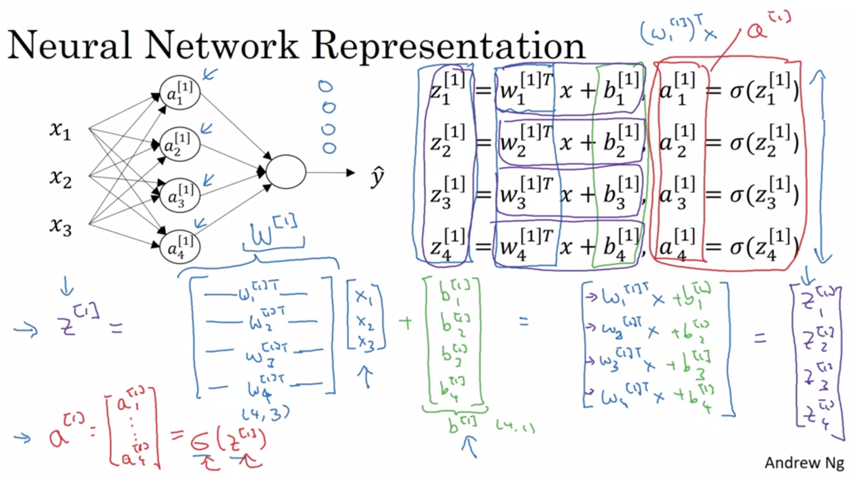

Rule of thumb for vectorization: stack different nodes in a layer vertically.

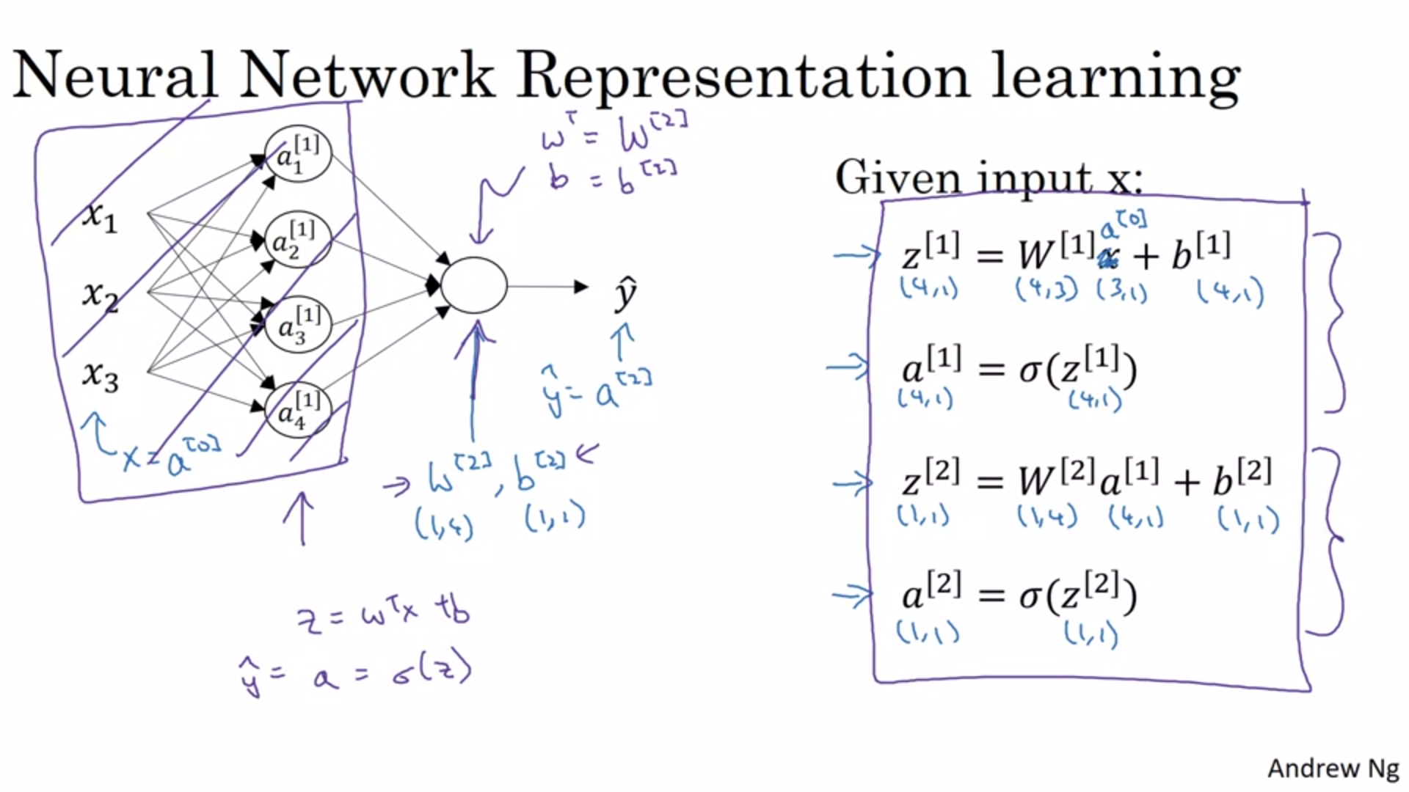

The last output unit is a lot like logistic regression (if we would cancel out the purple part).

We will see that we can compute the output of this network not only with one example at a time but with the entire training set.

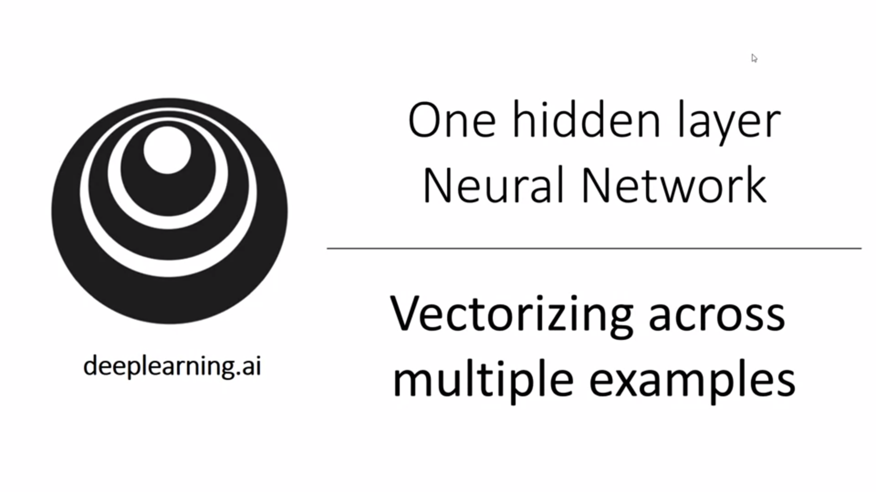

Similar to logistic regression we stack up different training examples in the columns of the matrix.

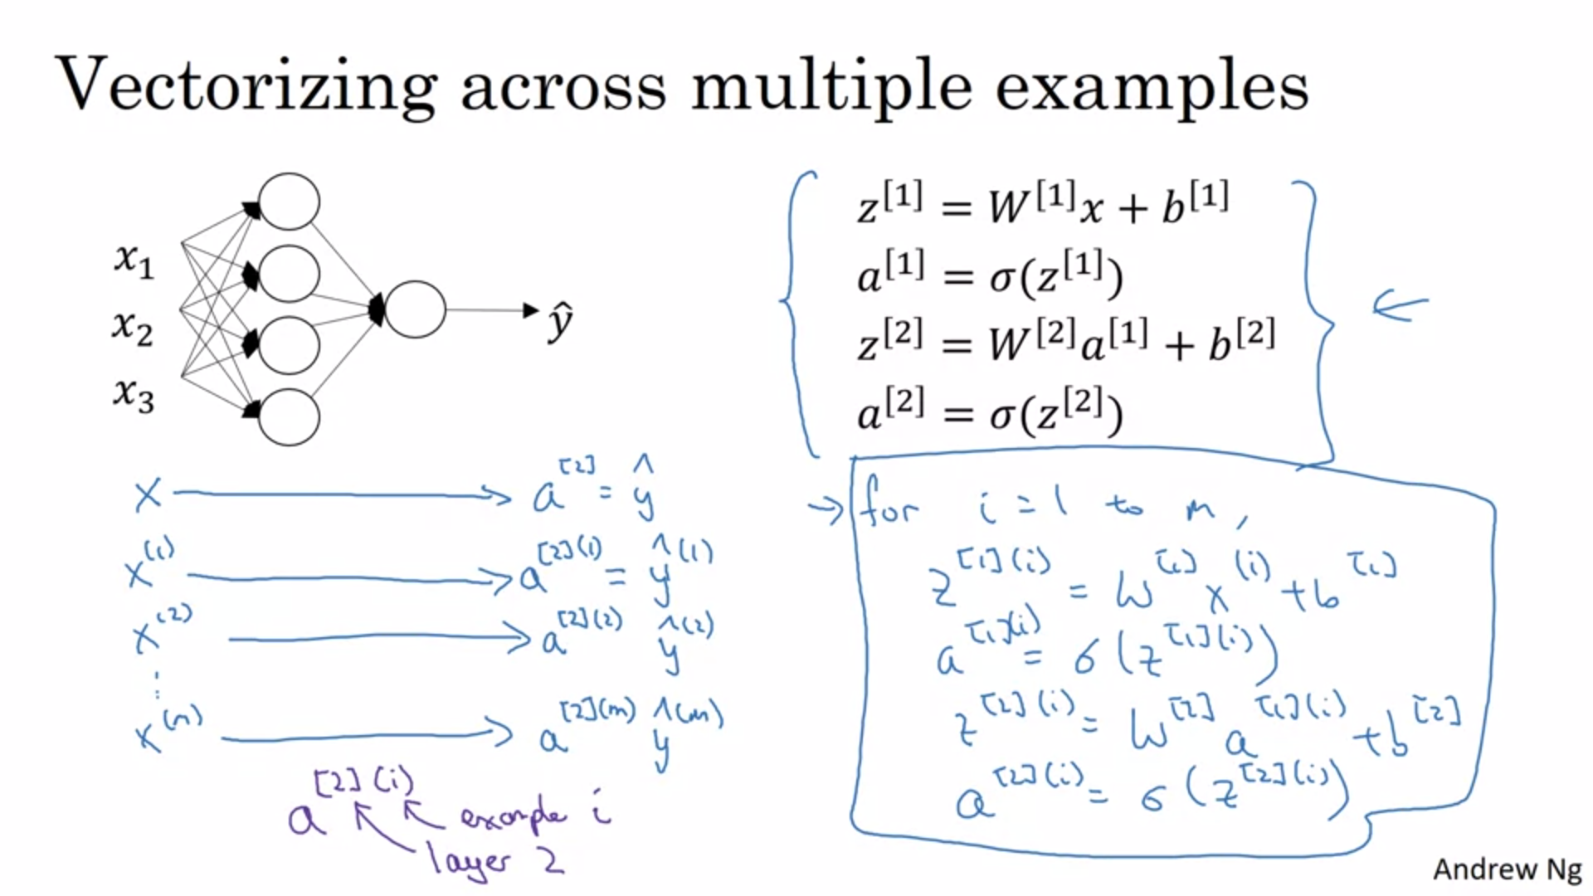

Here we use a for loop to compute for all the training examples. We want to vectorize that.

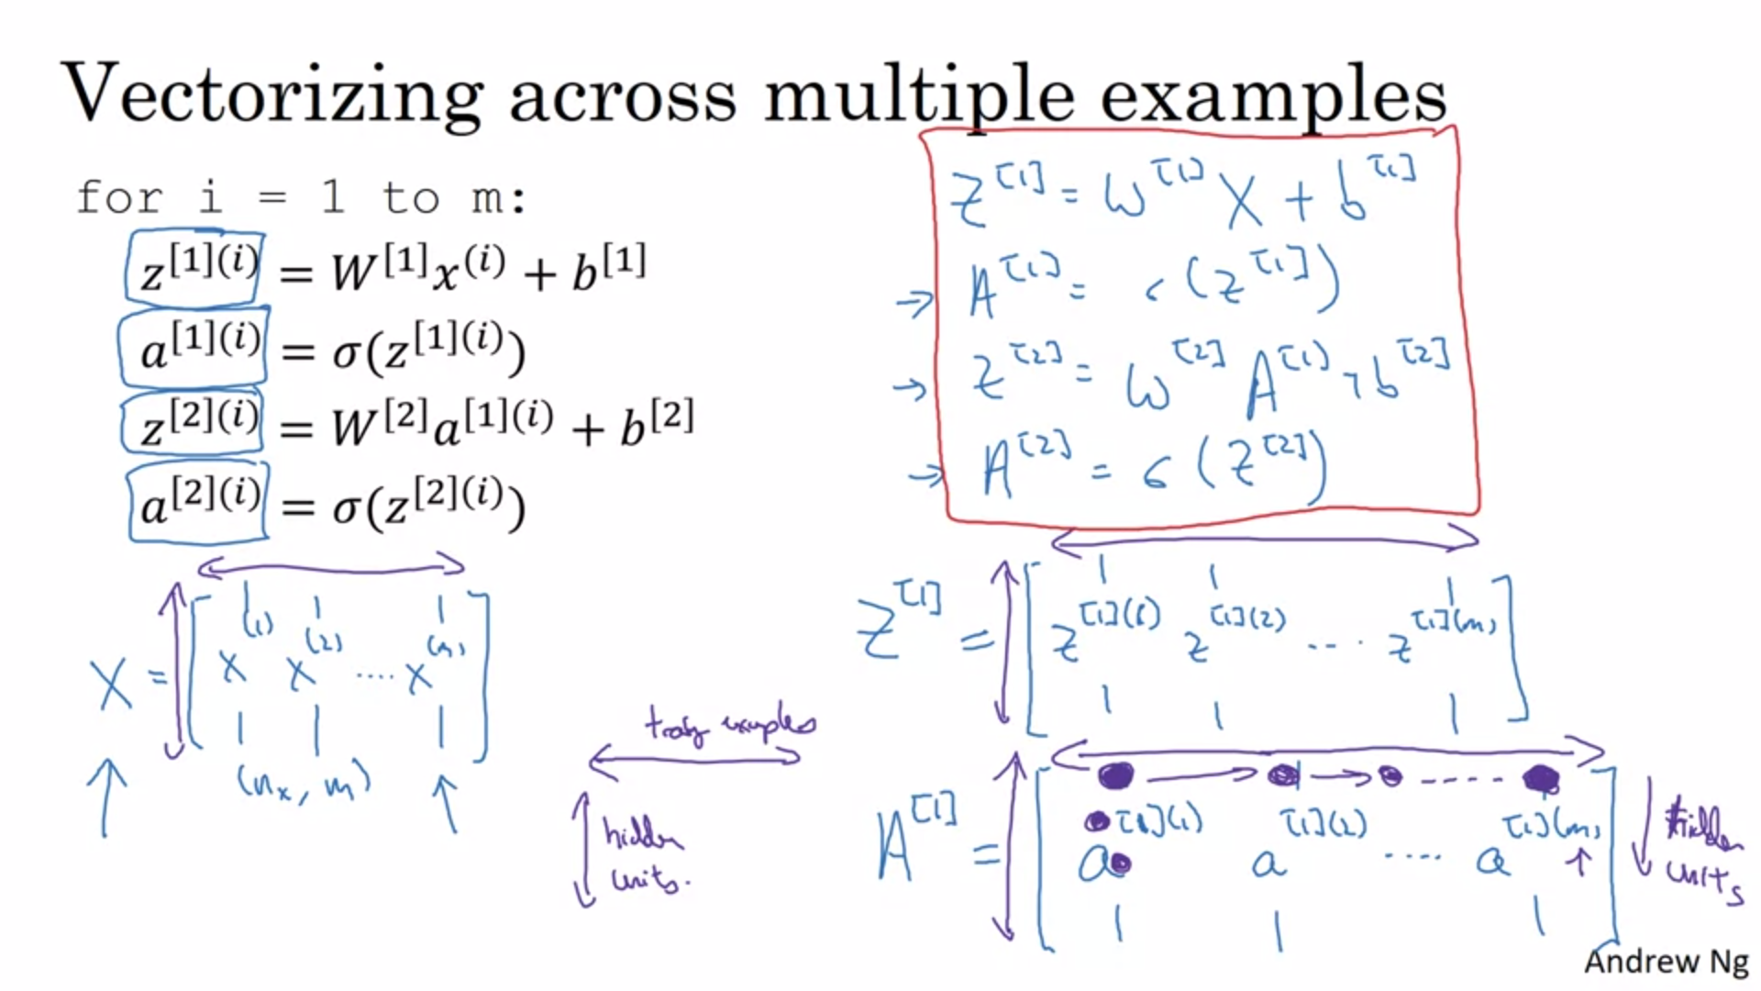

Horizontally we index training examples. Vertically we index different nodes in the neural network.

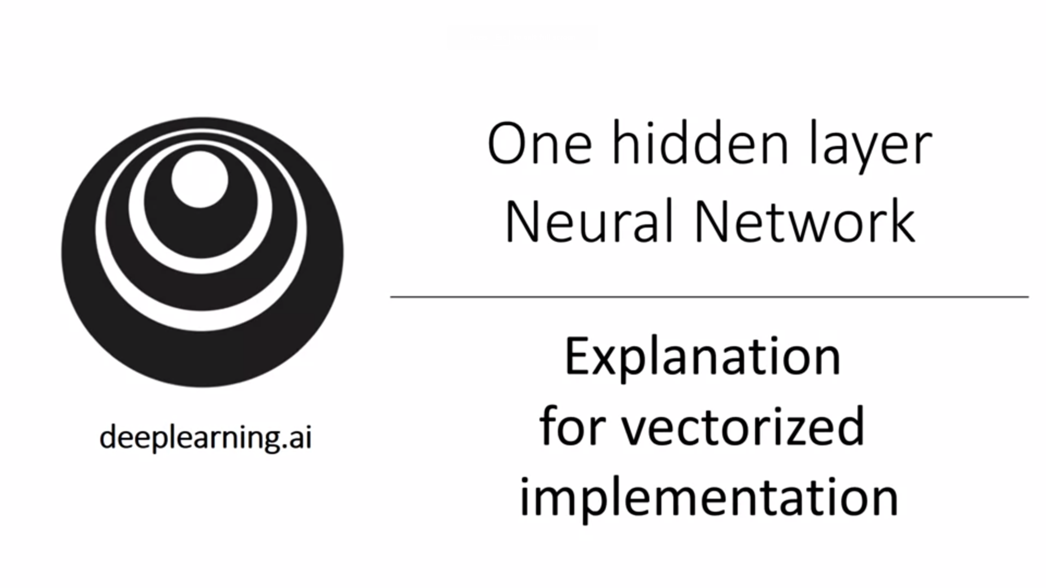

We want to give justification on why the equations that we wrote down for vectorization are correct.

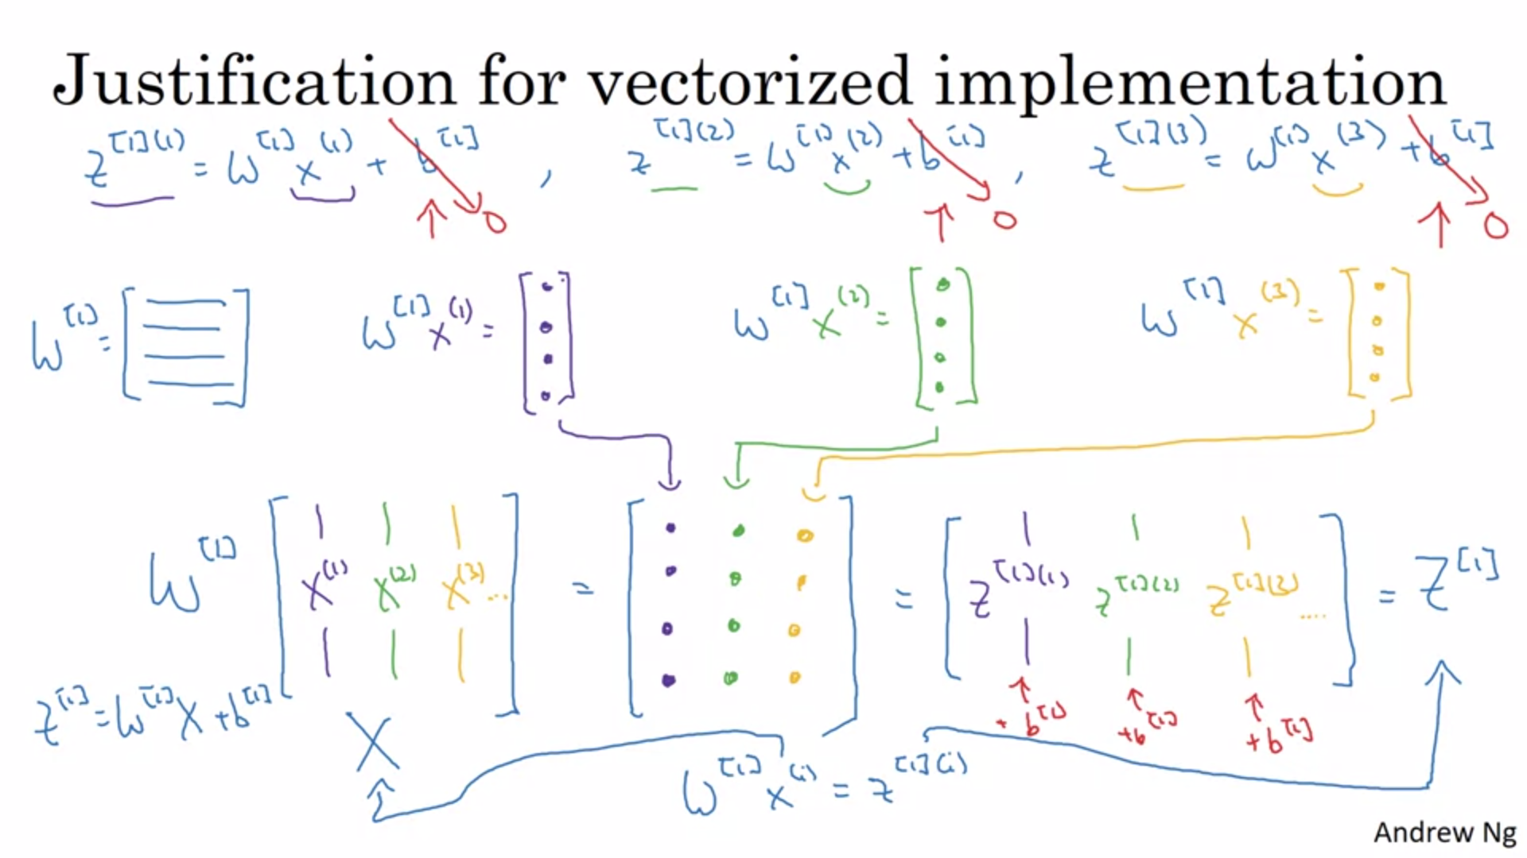

Here, to simplify, we ignore b (the argument is the same).

For each training example we get a column vector.

The matrix X is formed by stacking all training examples together (as columns).

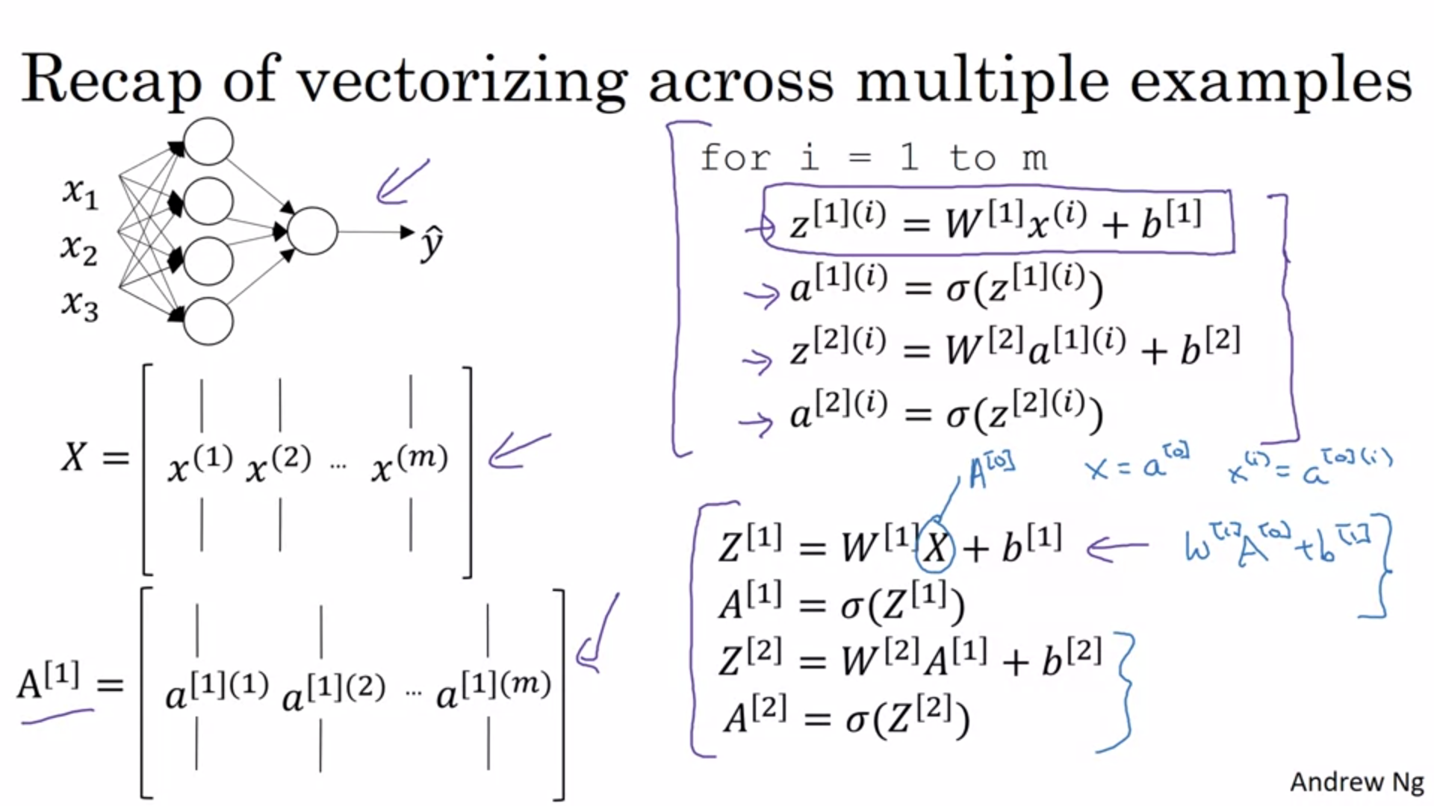

The reasoning to show the same for the other lines works the same way.

The different layers of the NN here are doing roughly the same.

The sigmoid function is one possible choice for activation functions but not necessarily the best one.

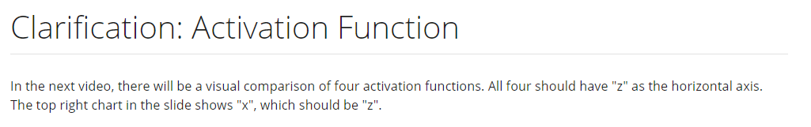

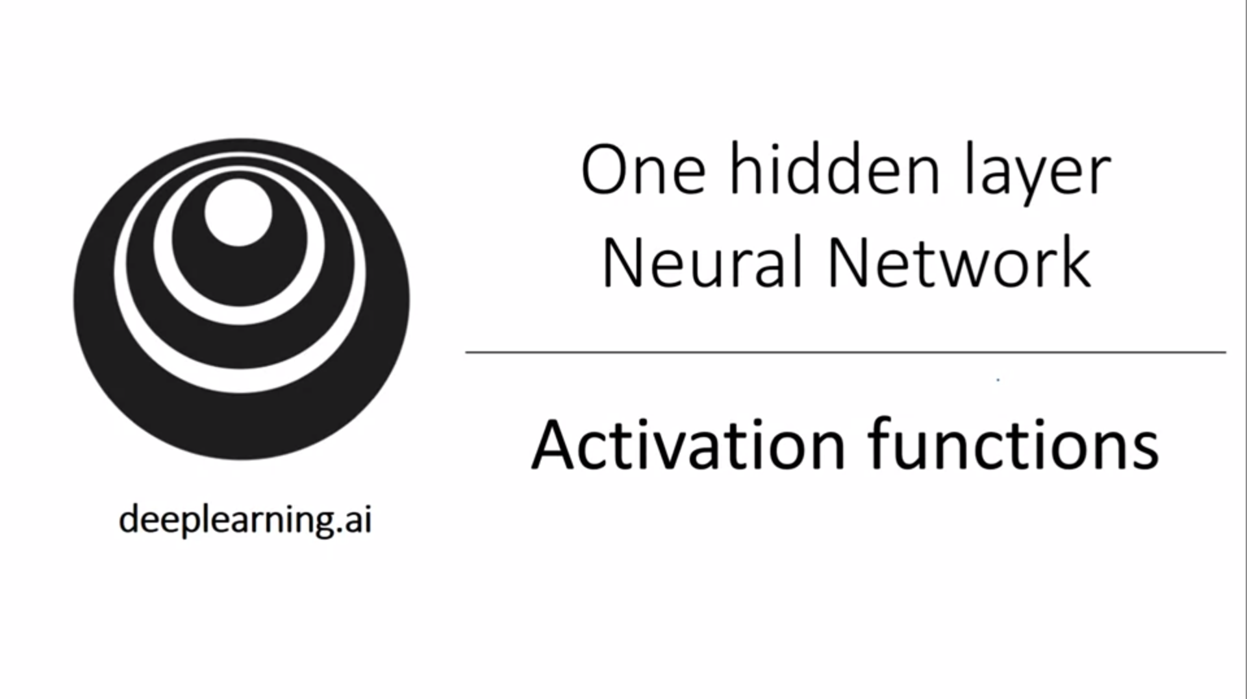

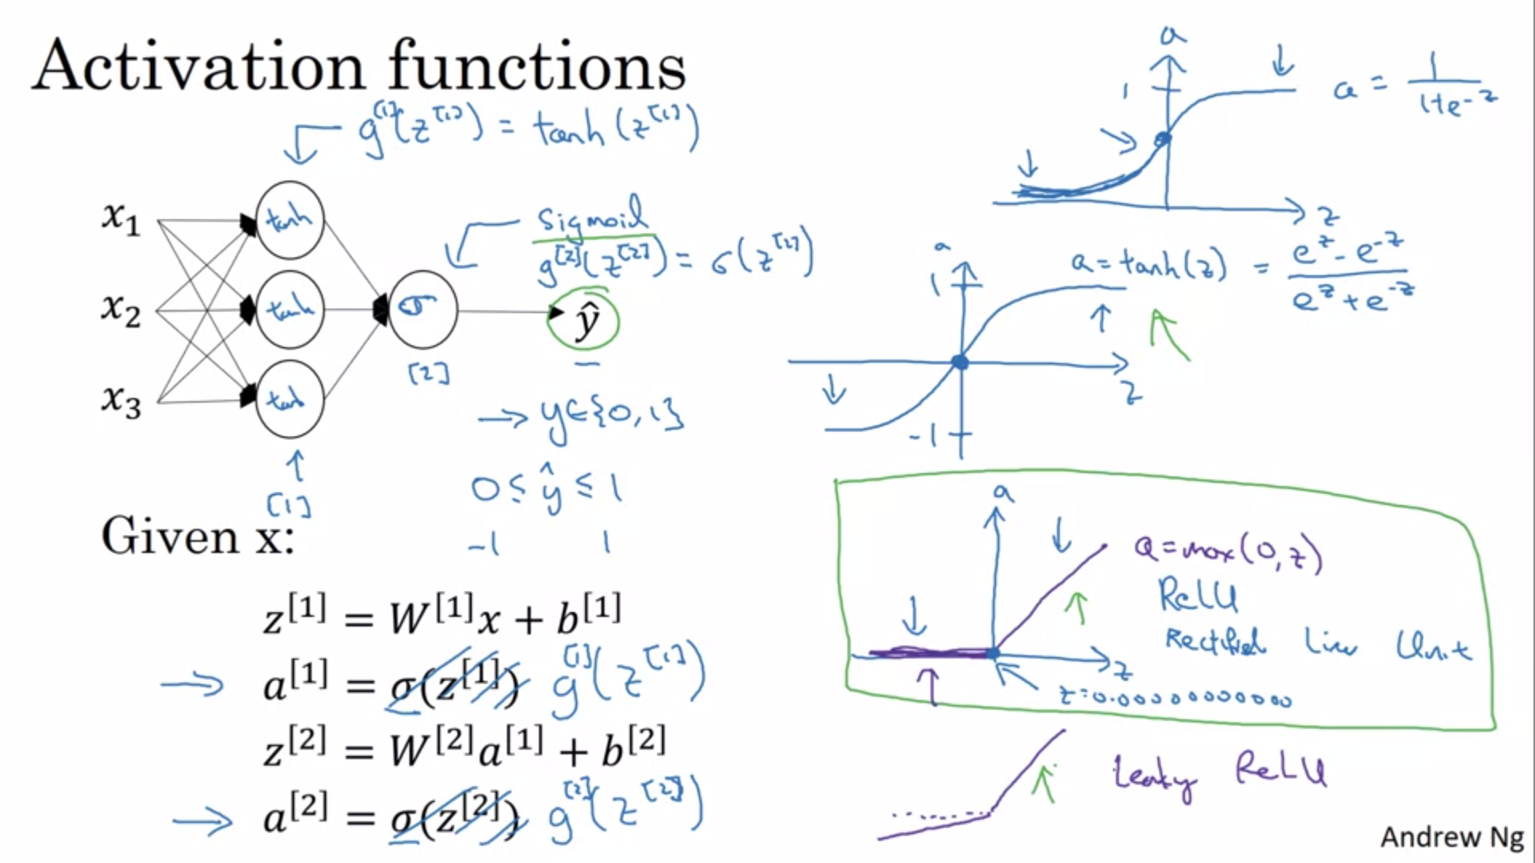

In the more general case we can have any non-linear function that is not the sigmoid function. The tanh function works almost always better than the sigmoid function.

Mathematically the tanh is a shifted sigmoid function.

With the tanh the activations have closer to a 0 mean. This has kind of the effect of centering the data, which makes learning for the next layer easier. Andrew almost never uses sigmoid anymore (tanh strictly superior). The only exception is the output layer for binary classification (to get probabilities).

The activation function can be different for different layers.

One of the downsides of both functions is that the slope/gradient gets very small for small and large z values. This gives rise to the popularity of the relu function.

In practice it does not matter that relu is not differentiable at z=0.

Relu is increasingly the default choice for activation functions.

Leaky Relu usually works better than Relu but is not used often in practice.

They do not slow down learning for small and large values of z. In practice enough of the hidden units have values for z>0 so that the 0 gradient for negative z values does not matter.

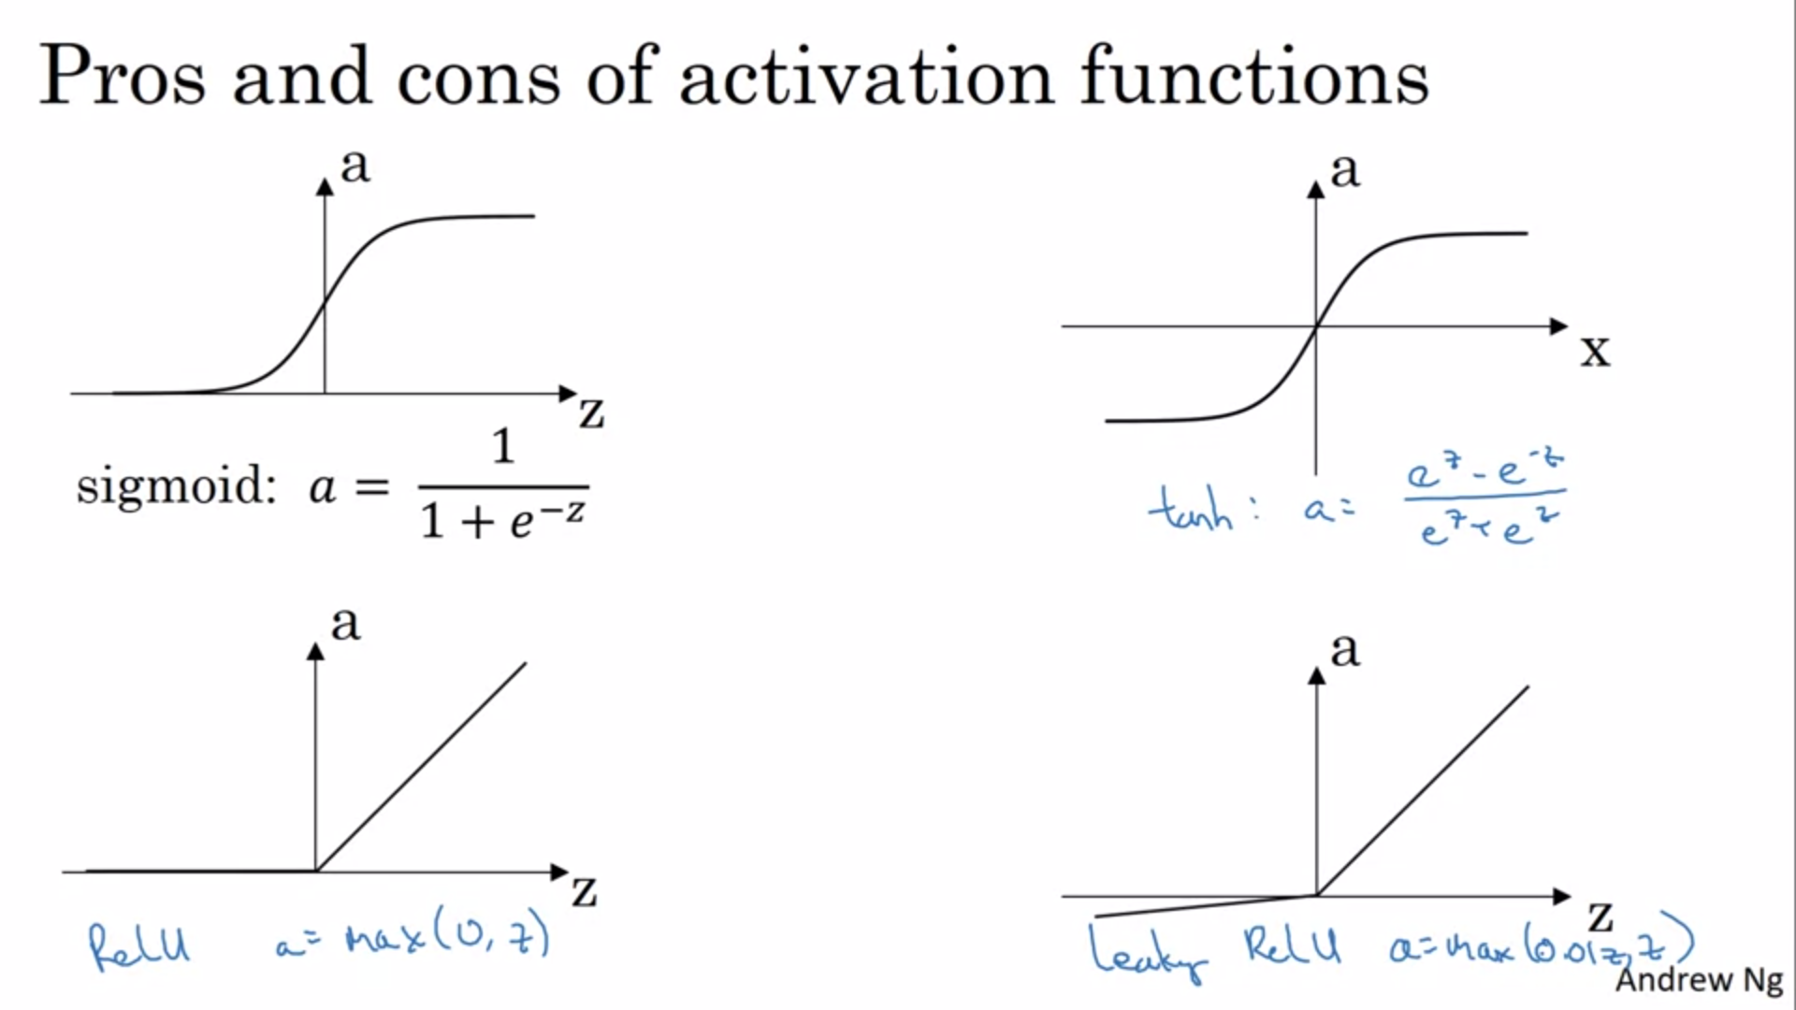

The constant of leaky relu can be another learning parameter.

There are a lot of choices to make in deep learning, ranging from number of hidden units to activation function and how you initialize the weights. It turns out that it is sometimes difficult to get good guidelines on what works well on particular problems. Always use development set to evaluate different choices. Only like that you can capture the idiosyncracies of a particular problem.

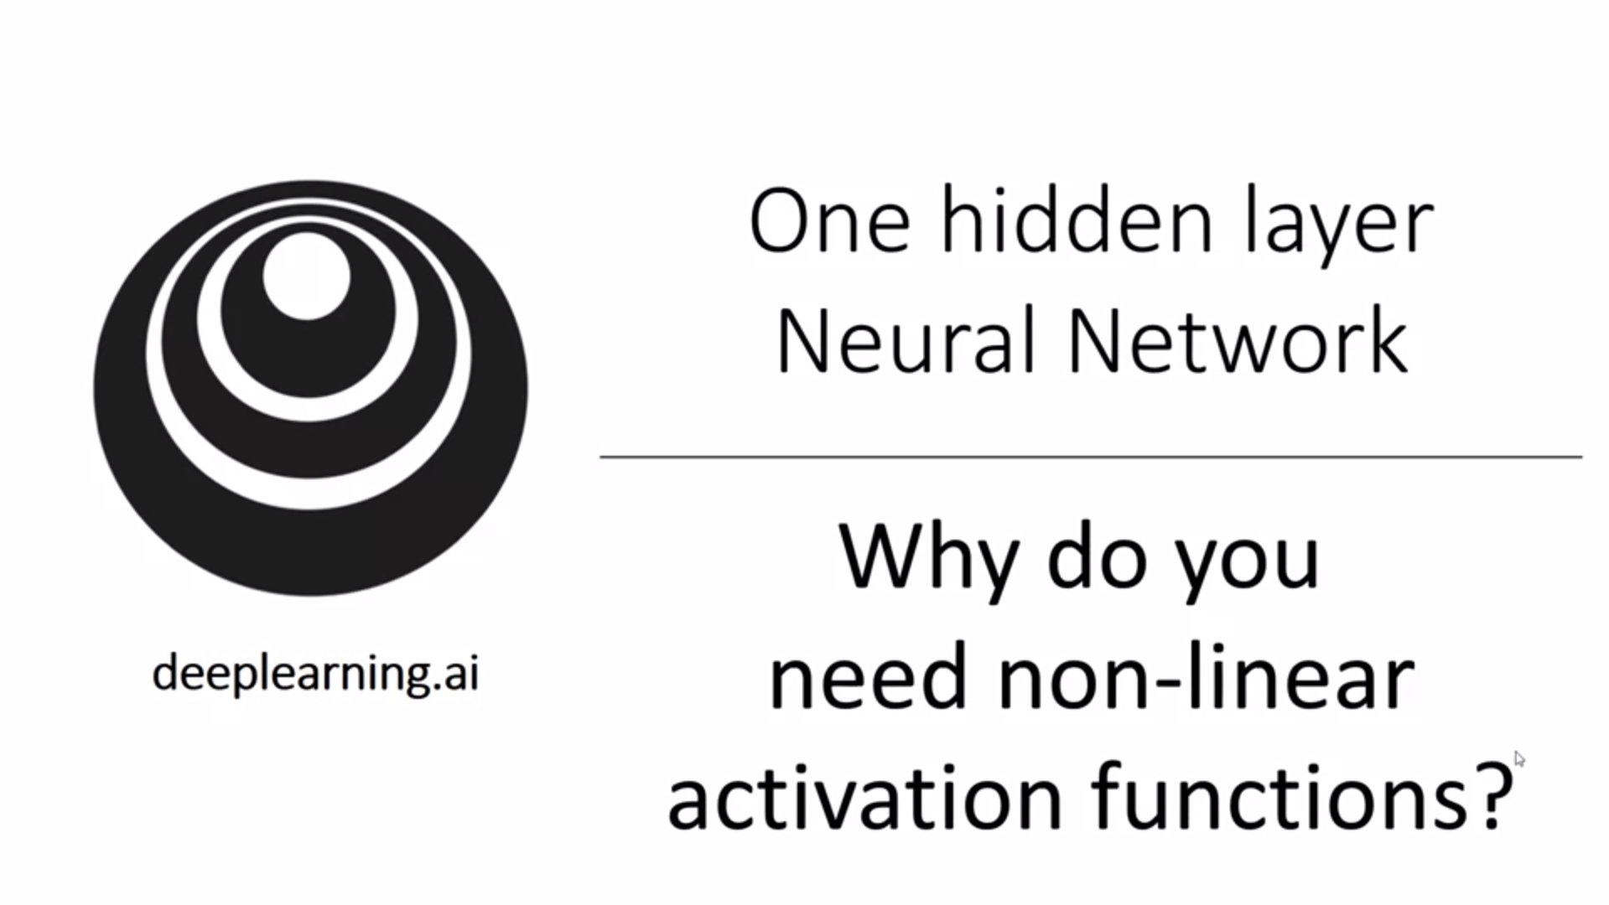

Why to use a non-linear activation function at all? It turns out that for the neural network to produce interesting functions, this is necessary!

Let’s see what would happen with linear activation.

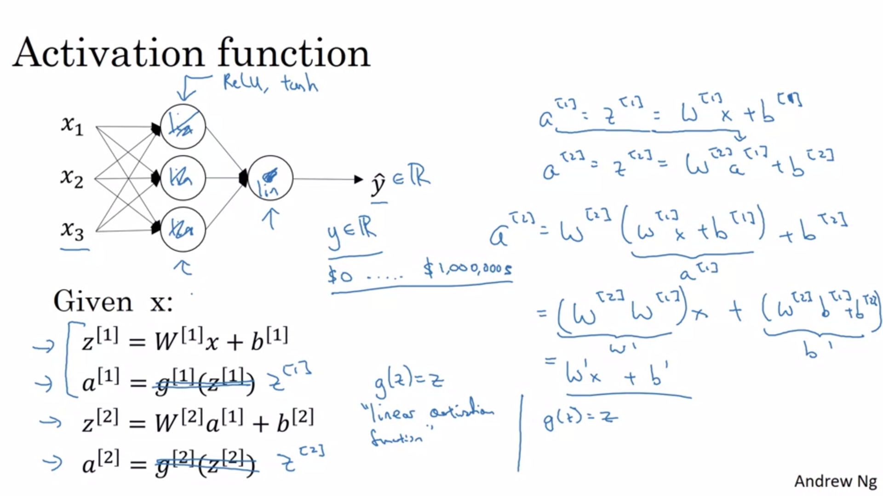

Even with multiple layers, the activation would be a linear combination of the input layer. That means that the NN could only learn linear functions. The hidden layers are basically useless. The composition of two linear functions is itself a linear function.

There is one place where a linear activation is useful: for the output layer of a regression problem (e.g. house prices; with y having real-valued output). Using a linear activation function is really rare. Even for the housing prices example you could use a relu function, so it should be an example where the output can also be negative.

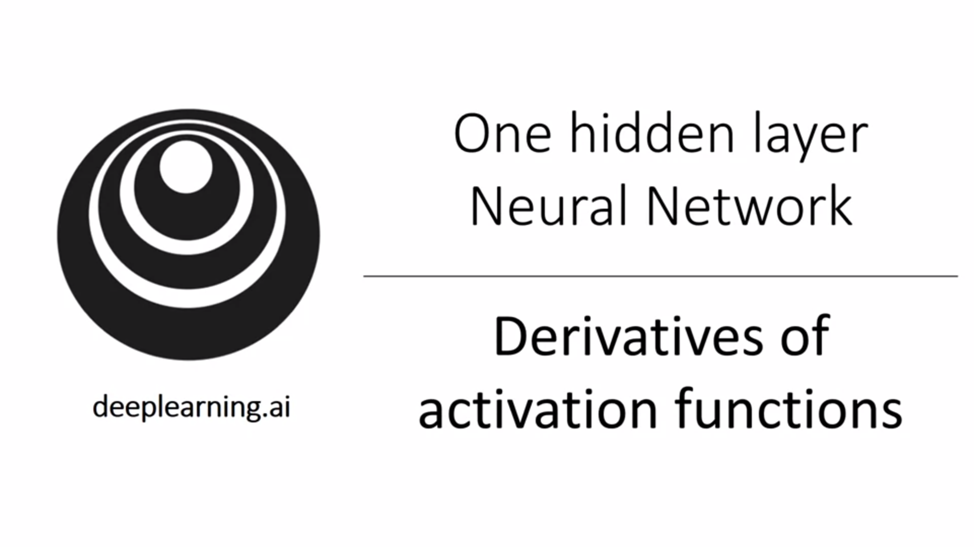

For backpropagation it is important to know the derivatives of activation functions.

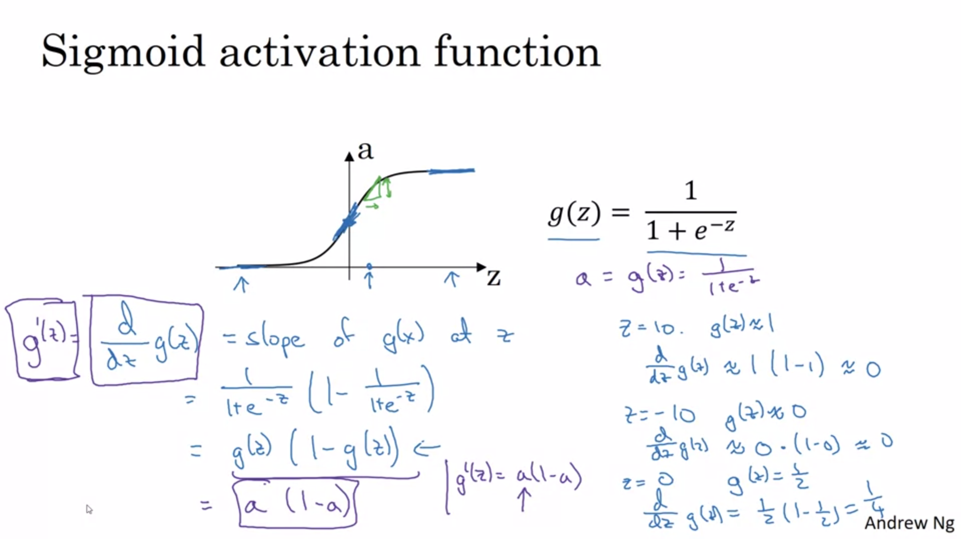

We did a sanity check on the derivative.

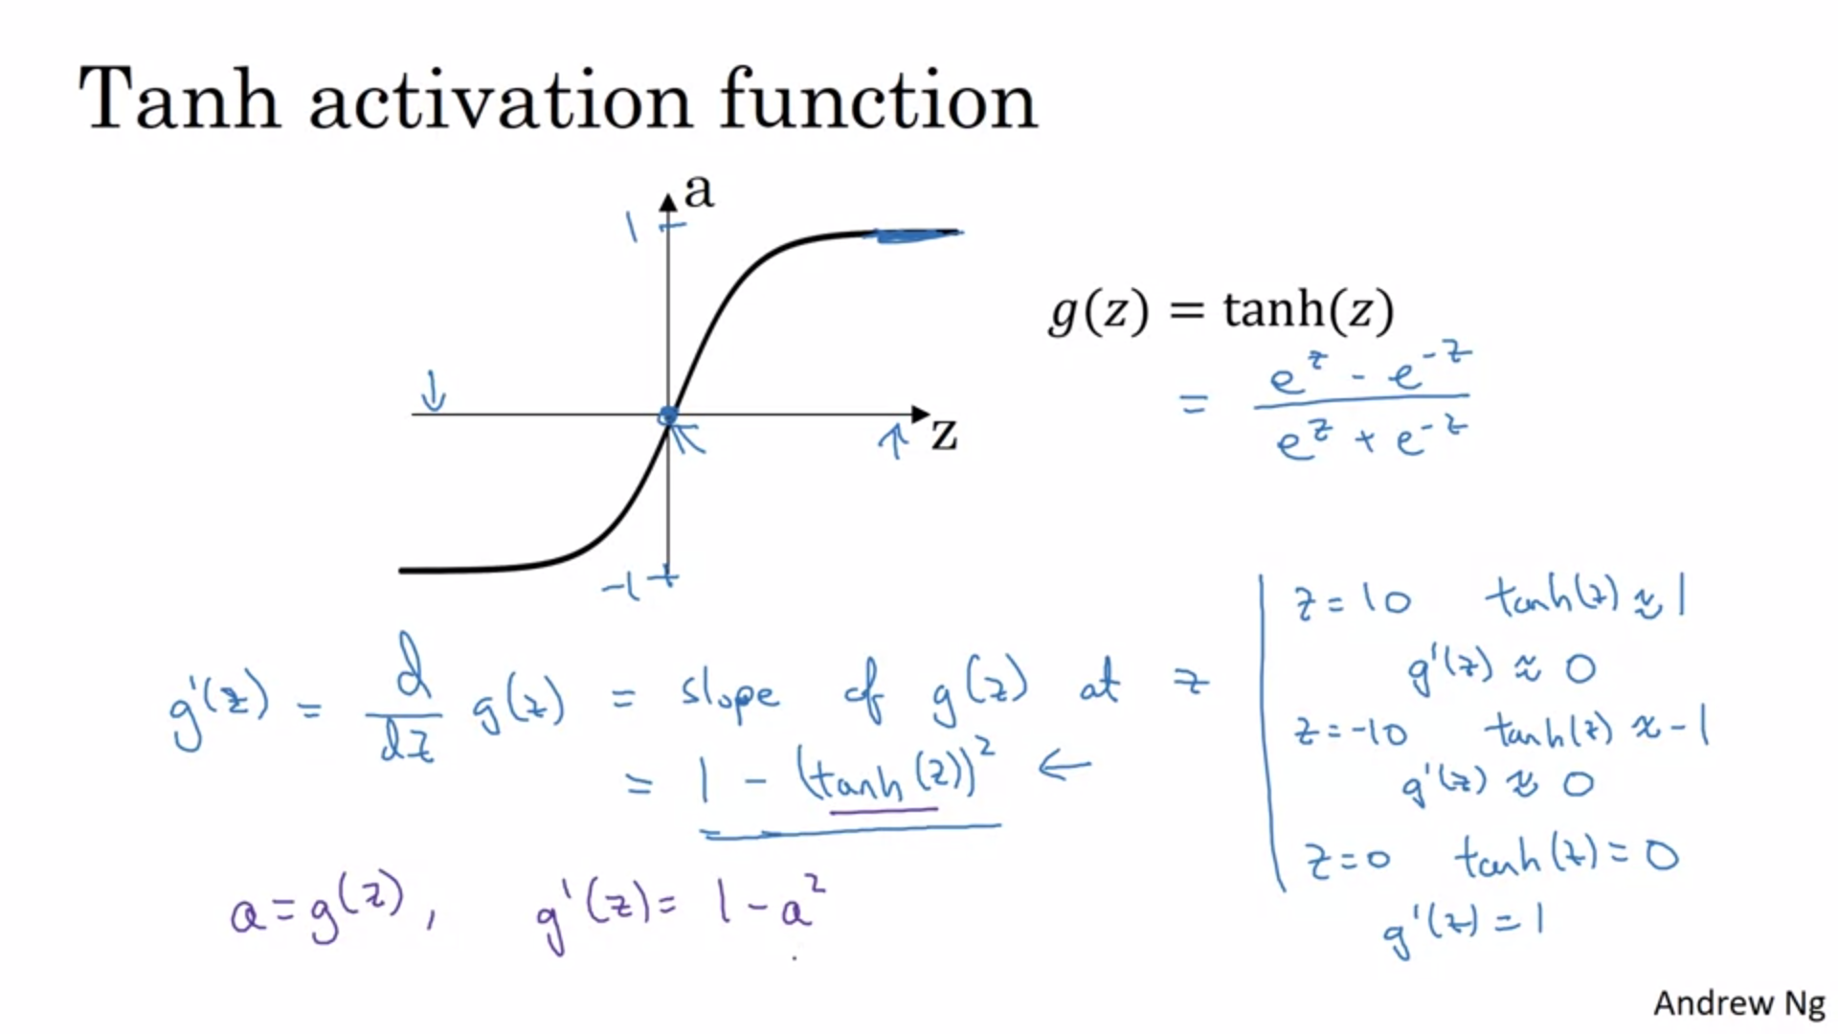

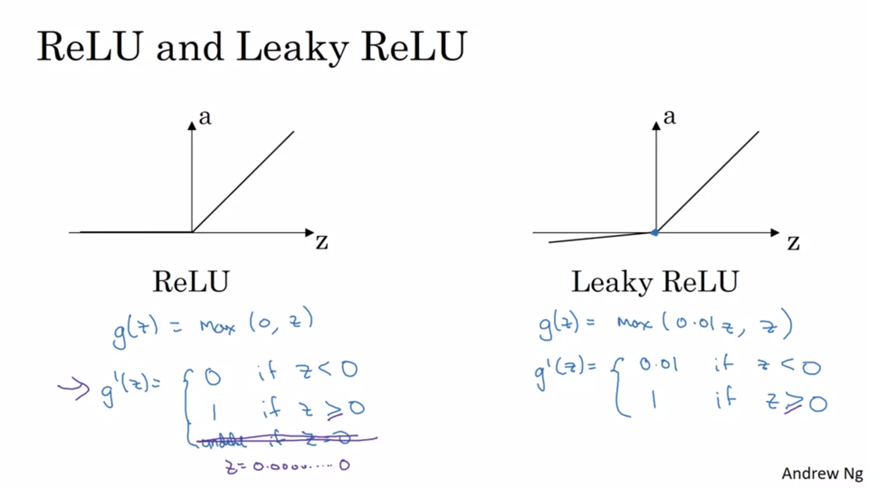

In software the z=0 does not really matter.

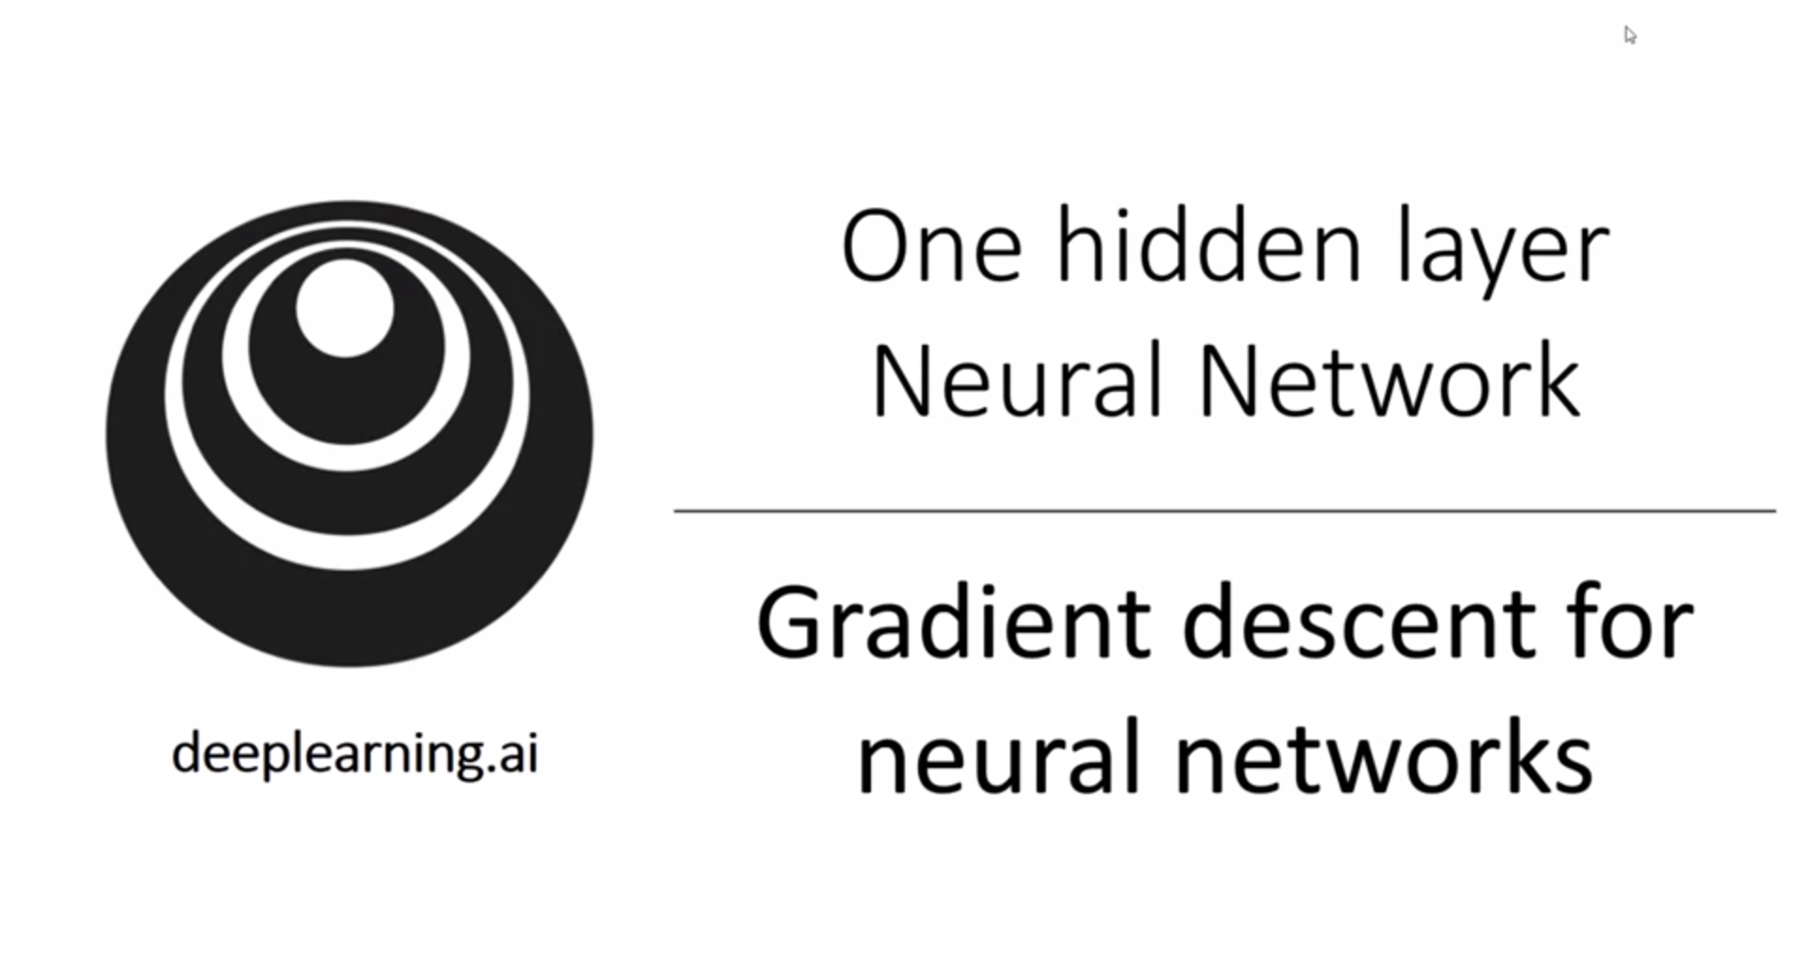

First we will get forward prop and backward prop to work. Andrew will share intuitions in the next video.

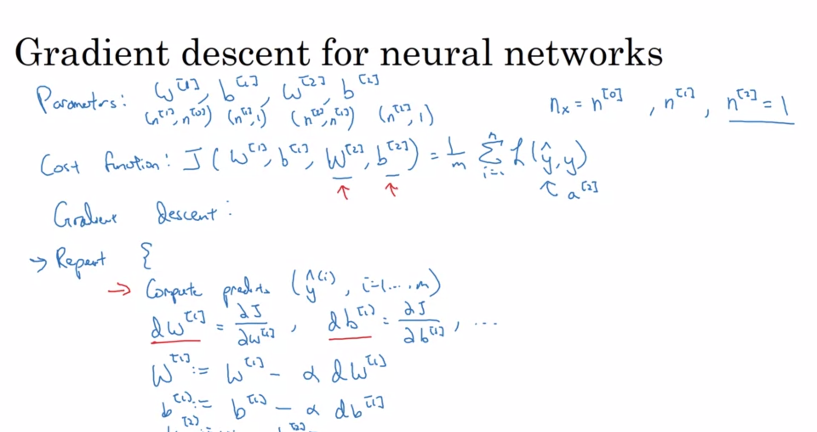

Recap: gradient descent algo consist of forward prop, backward prop and gradient descent update -> one iteration of gradient descent.

This is just a summary of the equations without explanation. It is a vectorized solution. The first three equations of backprop are very similar to logistic regression. Keepdims prevents Python from outputting rank-1 arrays.

Binary classification with sigmoid activation is already baked into the formula for dZ[2].

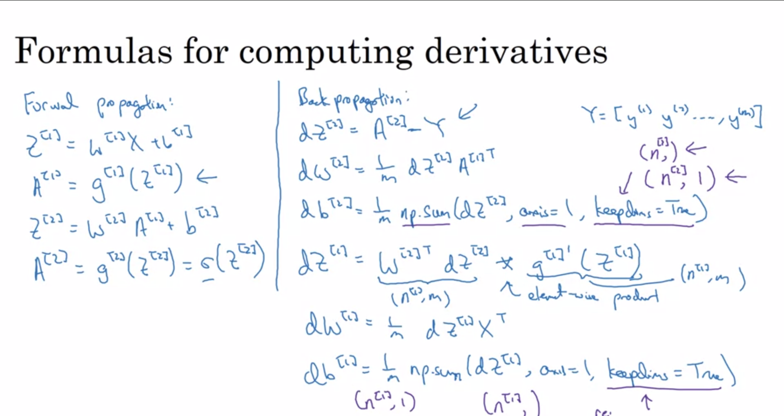

Now we will go into intuitions. It is possible to get the algorithm to work without understanding the derivation of these equations.

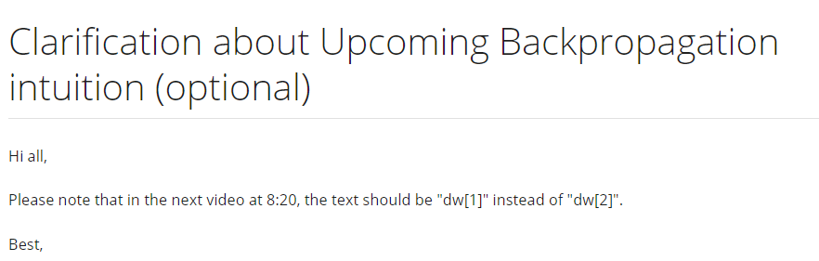

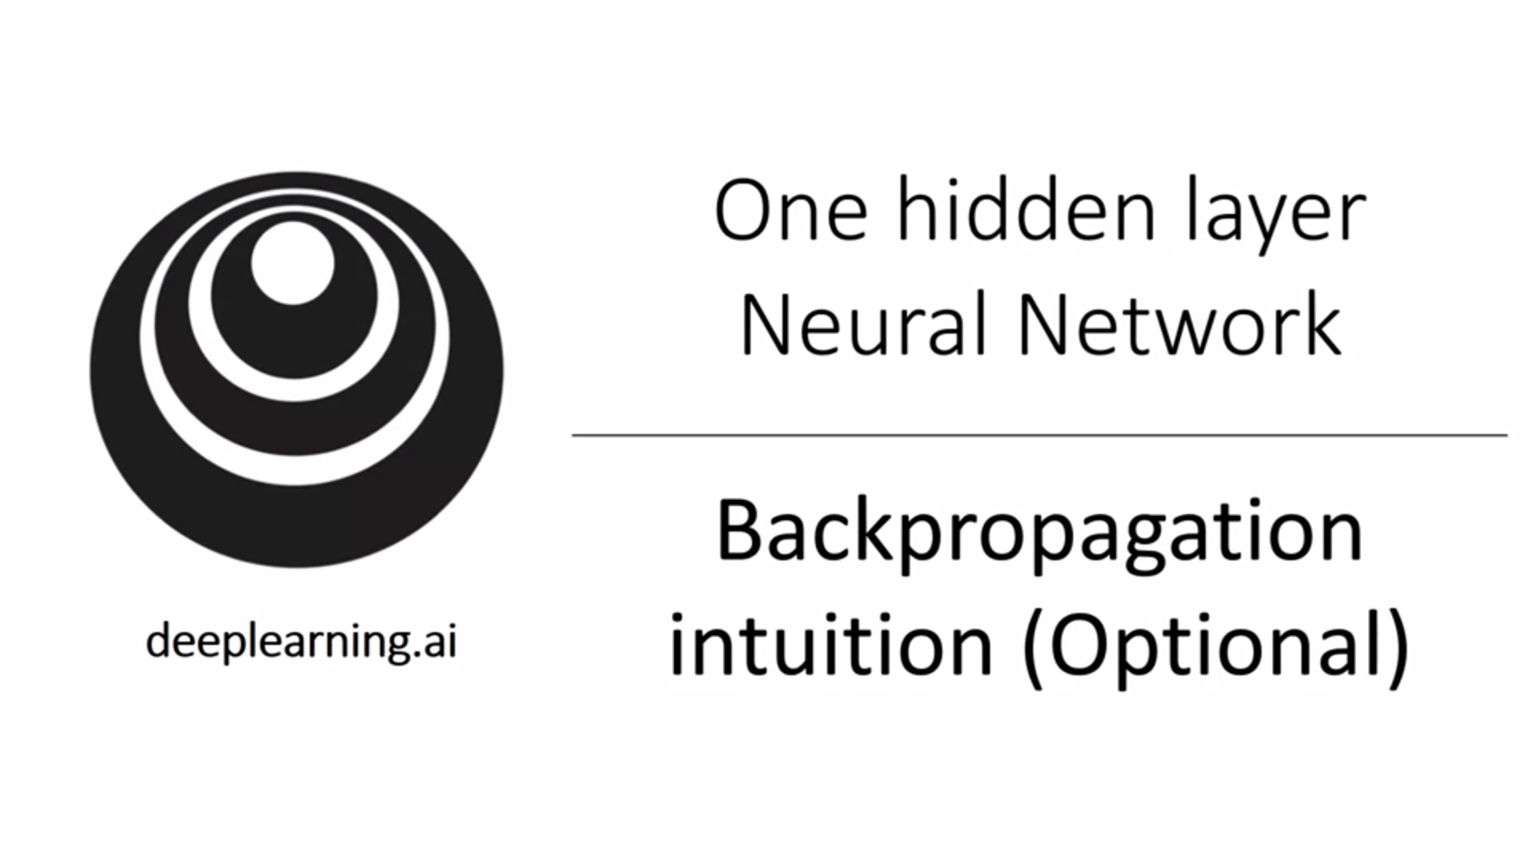

Use the computation graph to build intuition.

Recap logistic regression:

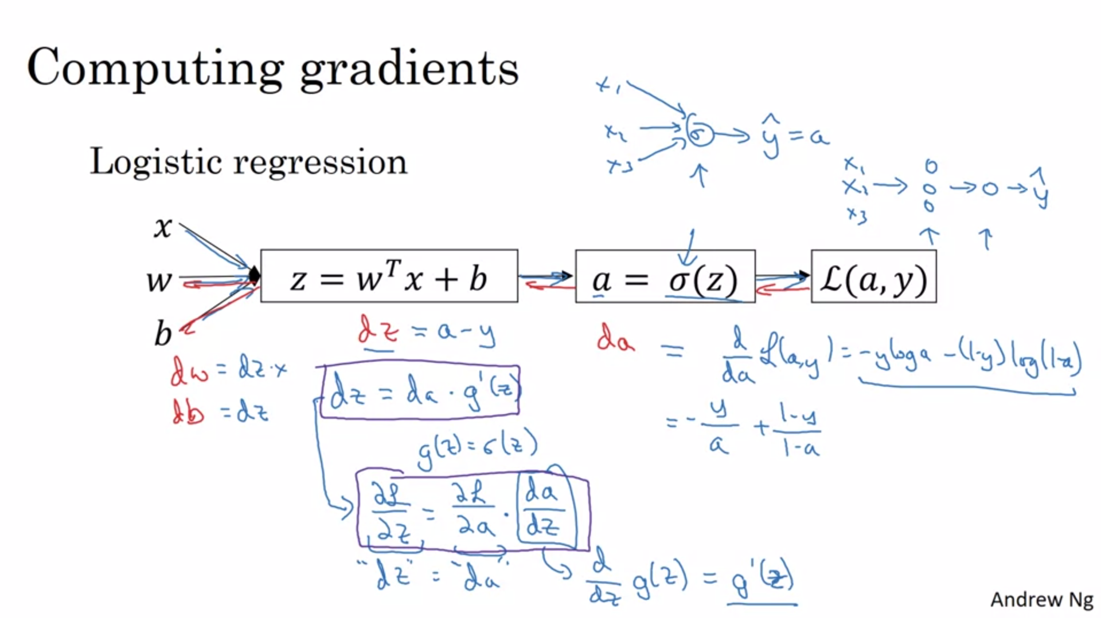

For our neural network we do the same, only we do it twice!

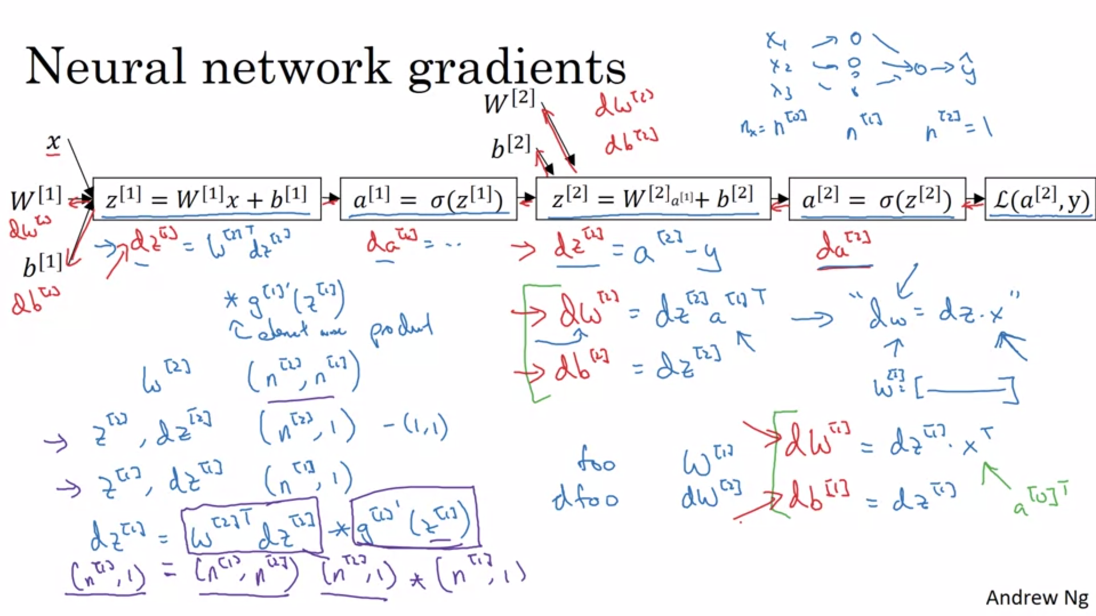

For supervised learning we do not need to take derivatives with respect to x.

In practice you can collapse da[2] and dz[2] step into one.

Until dz[2] it is very similar to logistic regression. There is a transpose now (because of the relationship between the dW[2] matrix and the dw column vector (for logistic regression).

Right top picture Is a dimension check.

Foo and dfoo always have the same dimension.

Always make sure that dimensions match up. Often this already solves a lot of implementational errors.

Observe the similarity between the different layers (makes sense).

So far we have worked with a single training example but now we want to vectorize.

First for forward prop:

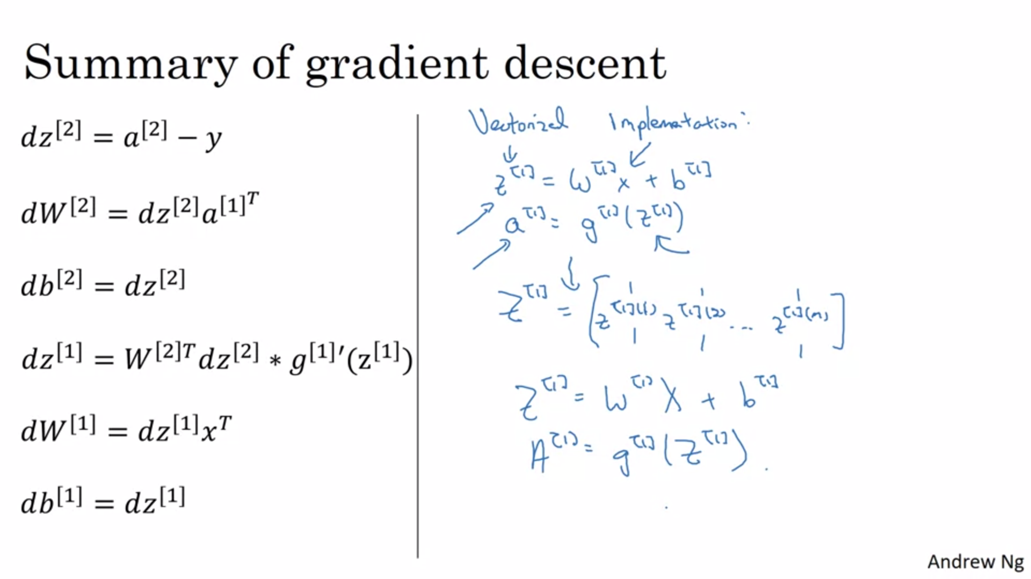

Now for backward prop:

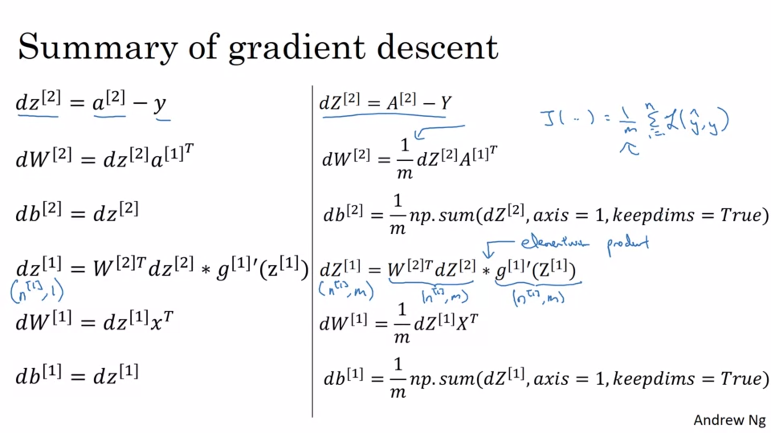

“\*” refers to element-wise product.

Plenty of practitioners only have a high level idea of deriving backprop.

Now let’s see how to initialize weights. We will see that it is important to initialize randomly instead of zero initialization.

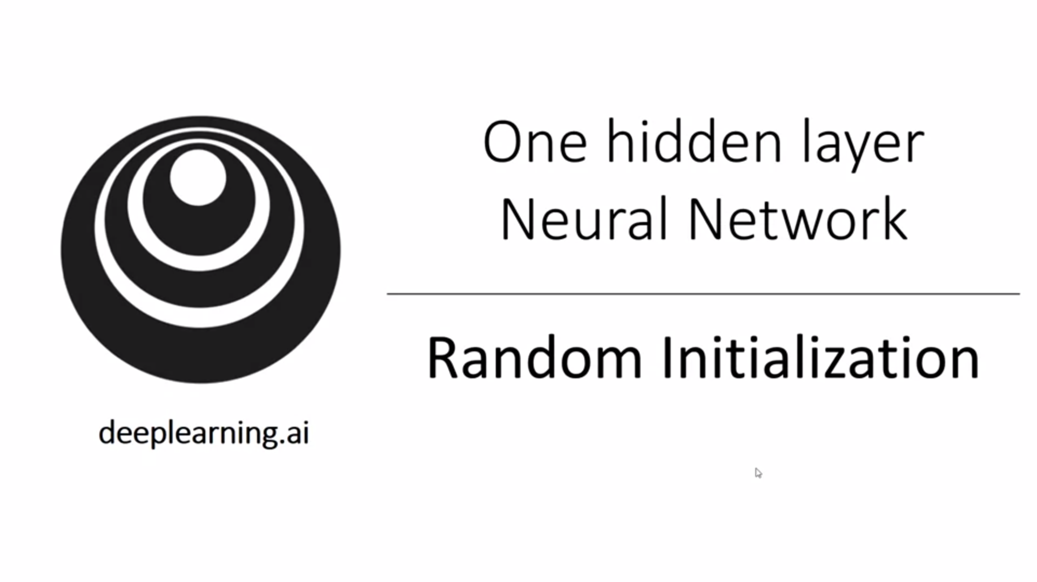

Neural networks (with hidden layers) won’t work with 0 initialization (for logistic regression it worked).

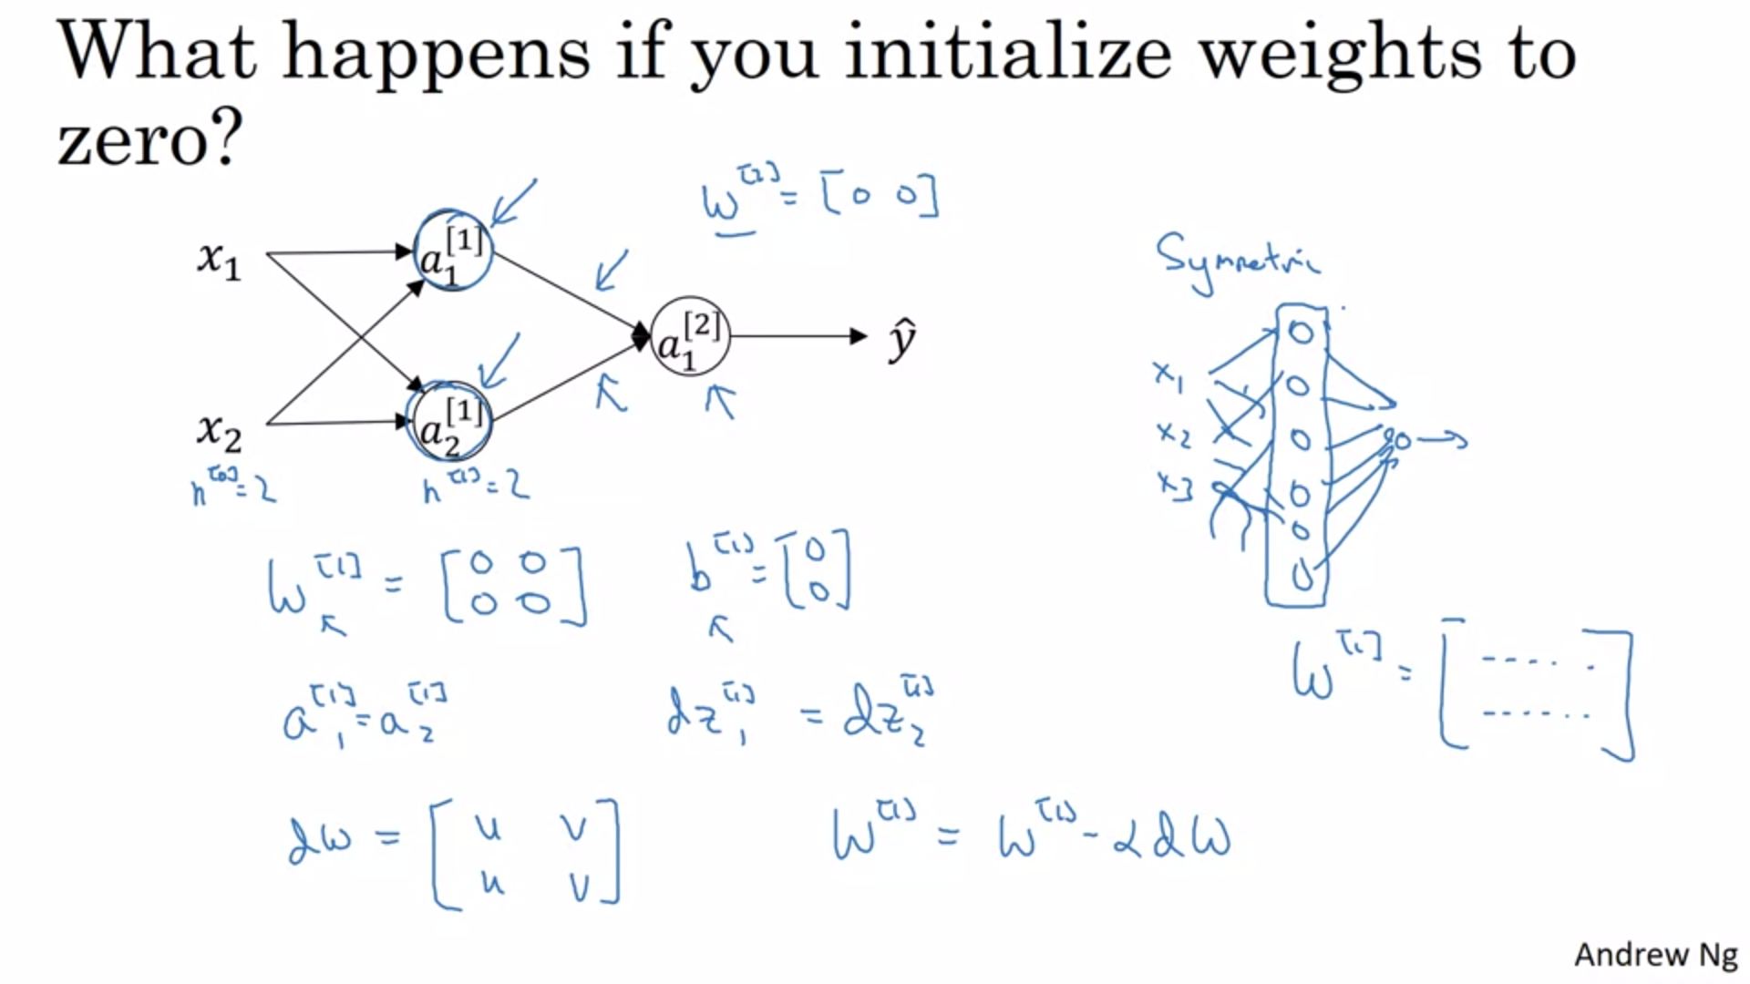

Initializing the bias terms to 0 is actually OK.

All activations will be equal with 0 initialization (they compute the same thing). Gradients will also be similar because of symmetry. Through proof by induction, after every single iteration of gradient descent, the two neurons will still calculate the exact same thing. Both hidden units will have the same influence on the output. In this case there is no point in having more than one hidden unit.

For larger neural networks a similar argument works. All hidden units will be symmetric.

The solution to this is to initialize parameters randomly.

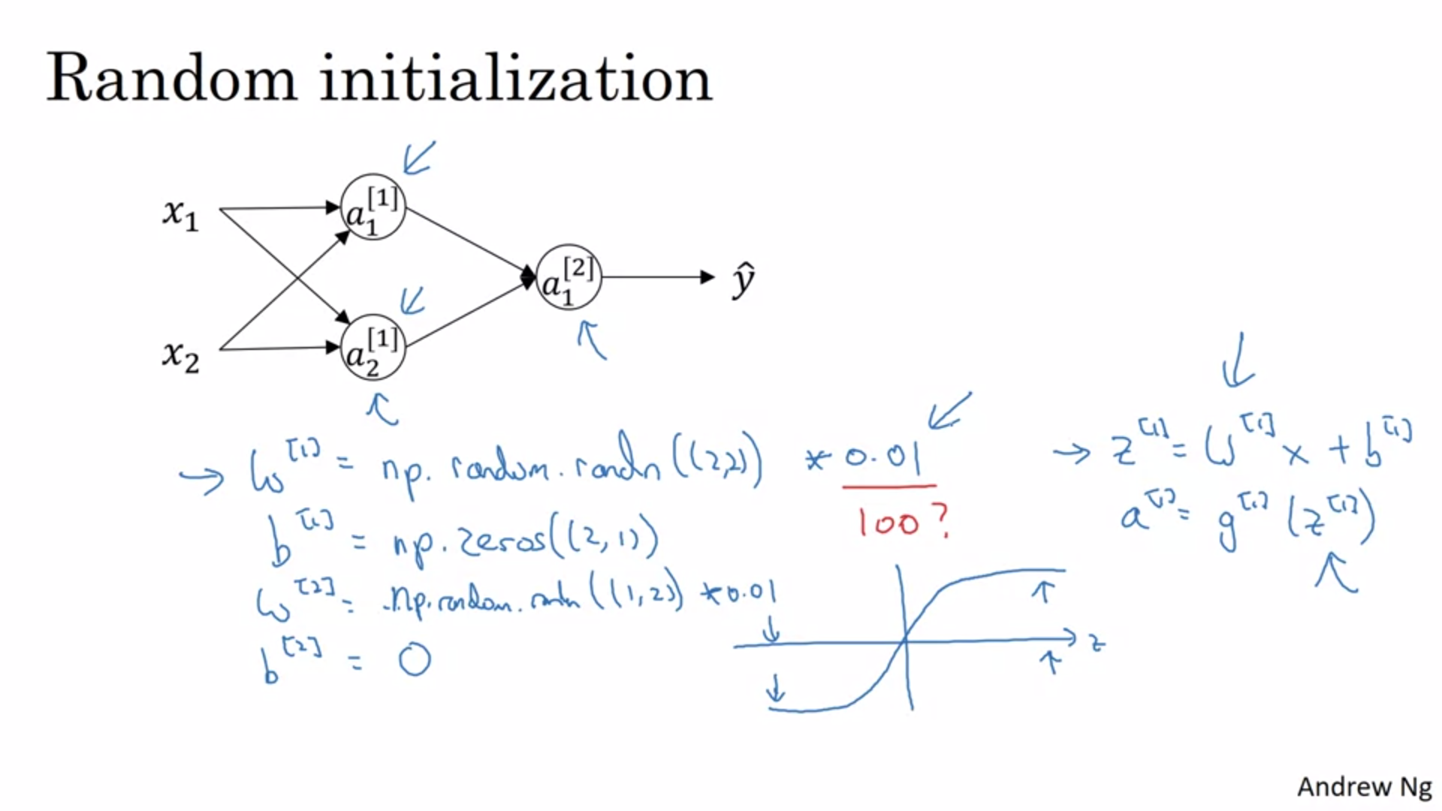

Initialize the parameters to very small random values (multiply by 0.01).

Why is the constant 0.01? We usually prefer to initialize the weights to very small random values because if you are using sigmoid or tanh then, if the weights are too large, when you compute the activation values the z’s will be very large or very low and learning would be very slow because the gradient would approach 0 (the sigmoid activation function would be saturated. If you do not have sigmoid or tanh activation functions this is less of an issue.

Sometimes there can be better constants than 0.01. For example, if you are training a very deep neural network you want to pick a different constant.